Name: Rishav Mondal

Roll no.: 210848

**ANALYZING THE LEVEL OF POLLUTION IN COAL MINES**

Data given:-

Index(['#', 'From', 'To (Interval: 15M)',

'Singrauli, Surya Kiran Bhawan Dudhichua PM10 (µg/m3)',

'Singrauli, Surya Kiran Bhawan Dudhichua PM2.5 (µg/m3)',

'Singrauli, Surya Kiran Bhawan Dudhichua NO (µg/m3)',

'Singrauli, Surya Kiran Bhawan Dudhichua NO2 (µg/m3)',

'Singrauli, Surya Kiran Bhawan Dudhichua NOX (ppb)',

'Singrauli, Surya Kiran Bhawan Dudhichua CO (mg/m3)',

'Singrauli, Surya Kiran Bhawan Dudhichua SO2 (µg/m3)',

'Singrauli, Surya Kiran Bhawan Dudhichua NH3 (µg/m3)',

'Singrauli, Surya Kiran Bhawan Dudhichua Ozone (µg/m3)',

'Singrauli, Surya Kiran Bhawan Dudhichua Benzene (µg/m3)'],

dtype='object')

**Original Data**

1. **PM 10**

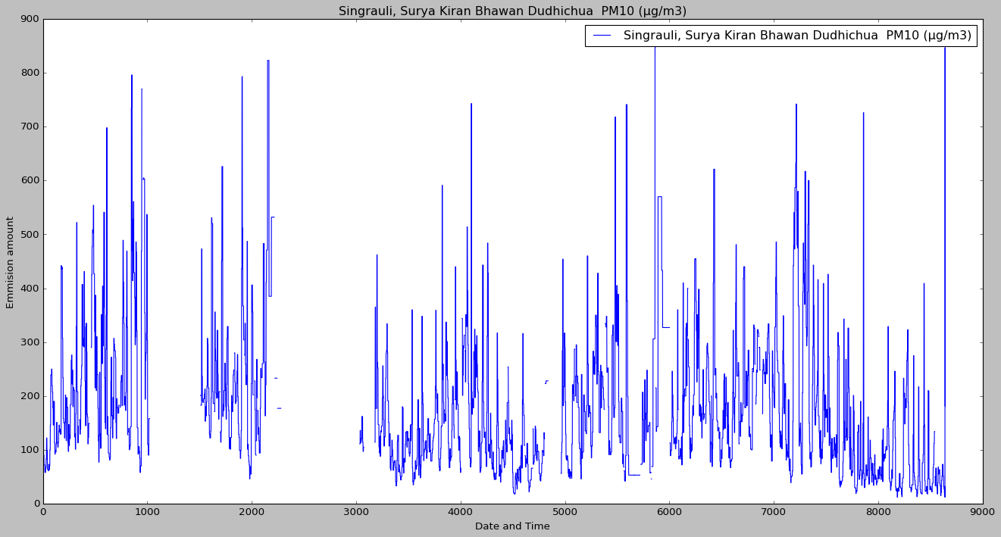

1. **PM 2.5**

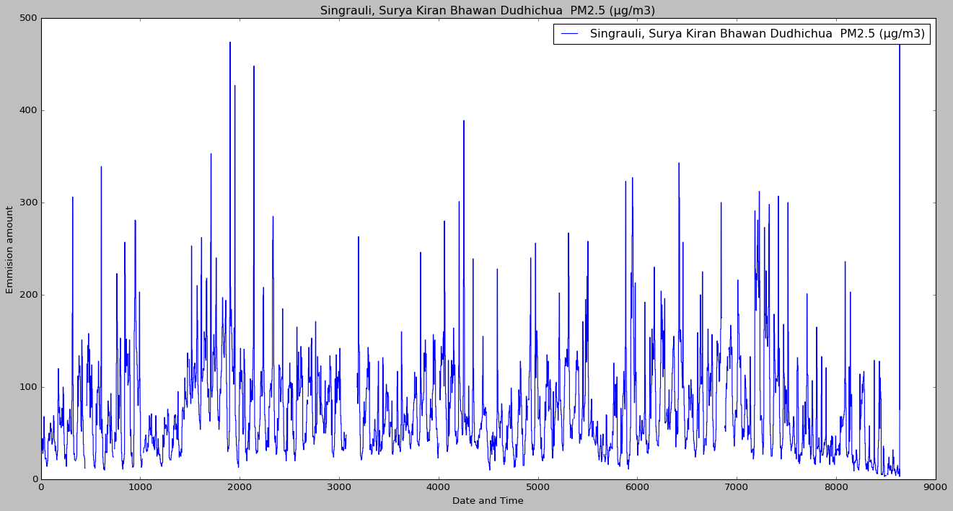

1. **NO**

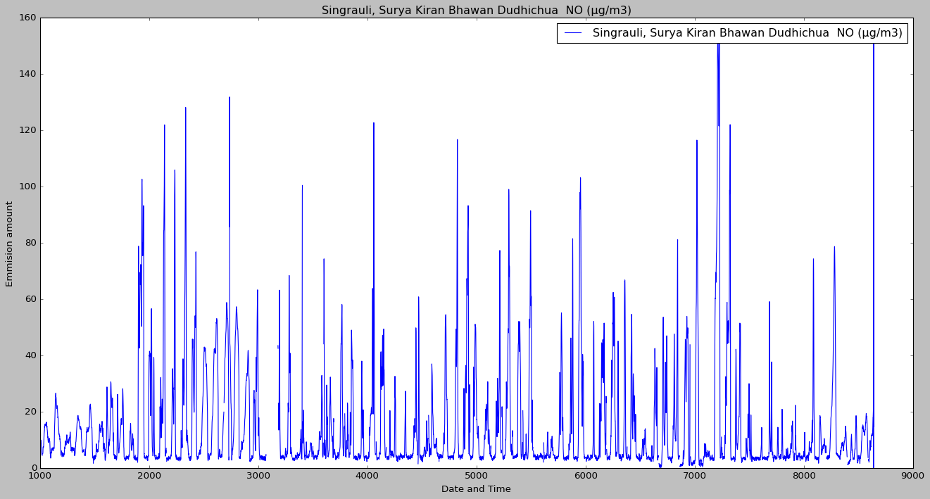

1. **NO2**

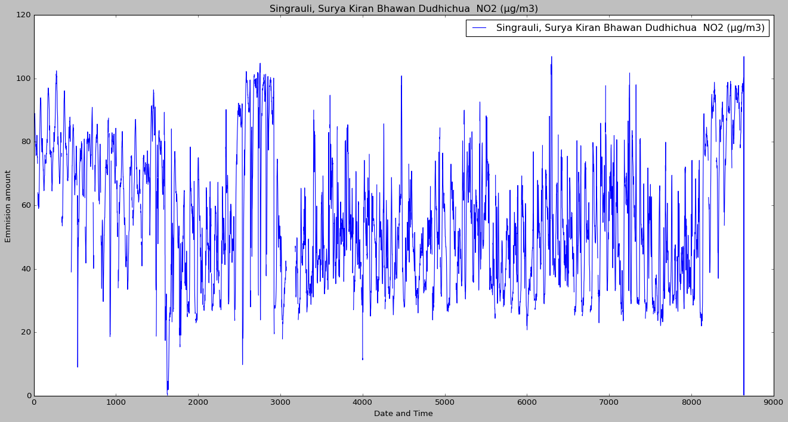

1. **NOX**

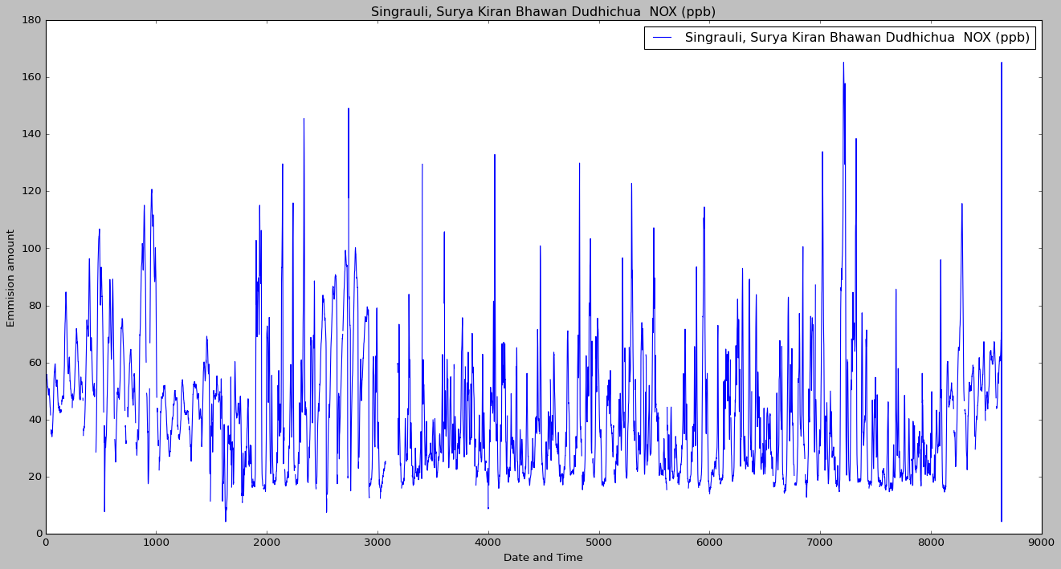

1. **CO**

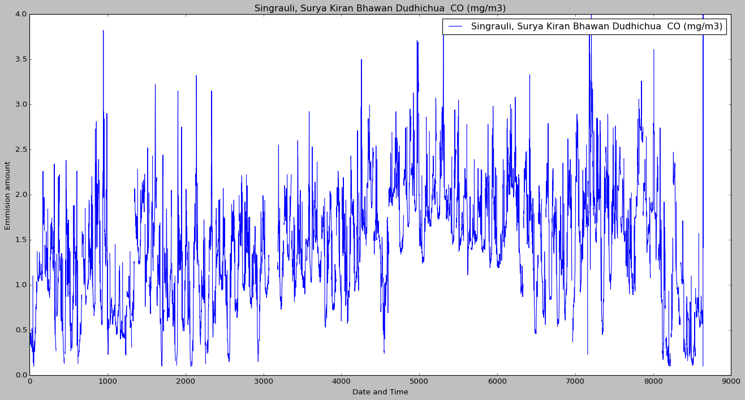

1. **SO2**



1. **NH3**



1. **Ozone**

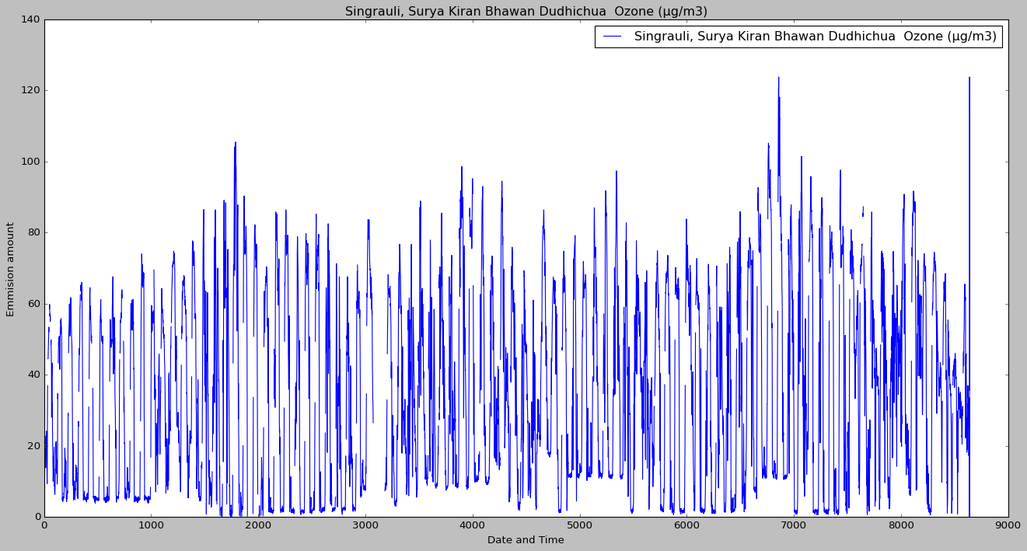

1. **Benzene**

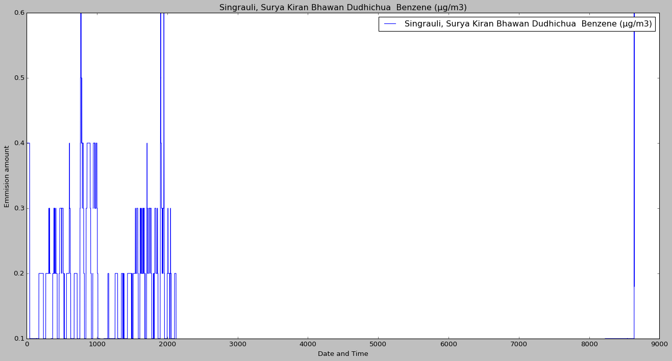

**INFERENCE**

1. **PM10**
2. ADF Test Statistic : -9.271489340273865
3. p-value : 1.323126731075347e-15
4. #Lags Used : 36
5. Number of Observations : 8606
6. strong evidence against the null hypothesis(Ho), reject the null hypothesis. Data is stationary
7. **PM2.5**
8. ADF Test Statistic : -11.515043607228588
9. p-value : 4.169885381467927e-21
10. #Lags Used : 36
11. Number of Observations : 8606
12. strong evidence against the null hypothesis(Ho), reject the null hypothesis. Data is stationary
13. **NO**
14. ADF Test Statistic : -16.28804095884647
15. p-value : 3.360060079155612e-29
16. #Lags Used : 5
17. Number of Observations : 8637
18. strong evidence against the null hypothesis(Ho), reject the null hypothesis. Data is stationary
19. **NO2**
20. ADF Test Statistic : -11.157092775788724
21. p-value : 2.848009370653664e-20
22. #Lags Used : 12
23. Number of Observations : 8630
24. strong evidence against the null hypothesis(Ho), reject the null hypothesis. Data is stationary
25. **NOX**
26. ADF Test Statistic : -13.786838330781565
27. p-value : 9.078928428822647e-26
28. #Lags Used : 6
29. Number of Observations : 8636
30. strong evidence against the null hypothesis(Ho), reject the null hypothesis. Data is stationary
31. **CO**
32. ADF Test Statistic : -10.629880377910954
33. p-value : 5.247722594942255e-19
34. #Lags Used : 9
35. Number of Observations : 8633
36. strong evidence against the null hypothesis(Ho), reject the null hypothesis. Data is stationary
37. **SO2**
38. ADF Test Statistic : -18.591920747710635
39. p-value : 2.07308780515237e-30
40. #Lags Used : 5
41. Number of Observations : 8637
42. strong evidence against the null hypothesis(Ho), reject the null hypothesis. Data is stationary
43. **NH3**
44. ADF Test Statistic : -2.988984761288293
45. p-value : 0.035935968549821944
46. #Lags Used : 30
47. Number of Observations : 8612
48. strong evidence against the null hypothesis(Ho), reject the null hypothesis. Data is stationary
49. **Ozone**
50. ADF Test Statistic : -20.70972130016281
51. p-value : 0.0
52. #Lags Used : 35
53. Number of Observations : 8607
54. strong evidence against the null hypothesis(Ho), reject the null hypothesis. Data is stationary
55. **Benzene**
56. ADF Test Statistic : -11.892410596355816
57. p-value : 5.82674854140046e-22
58. #Lags Used : 37
59. Number of Observations : 8605
60. strong evidence against the null hypothesis(Ho), reject the null hypothesis. Data is stationary

**ACF PACF Plots**

**PM10**

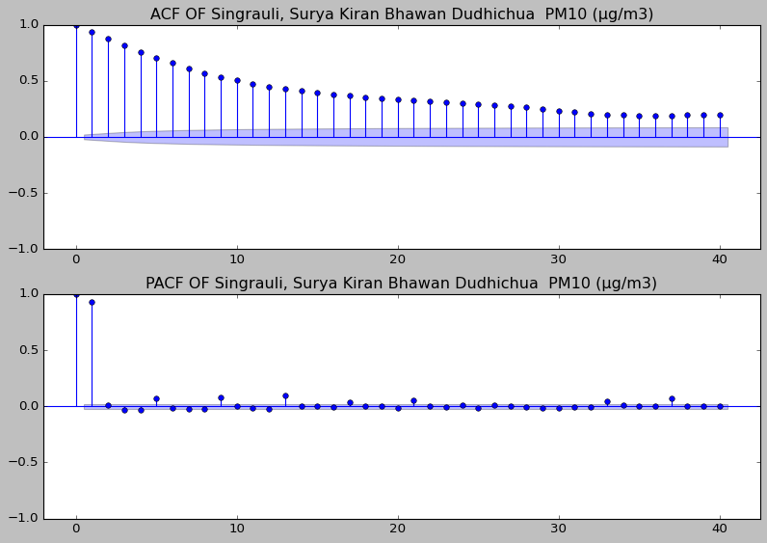

PM2.5(ug/m3)

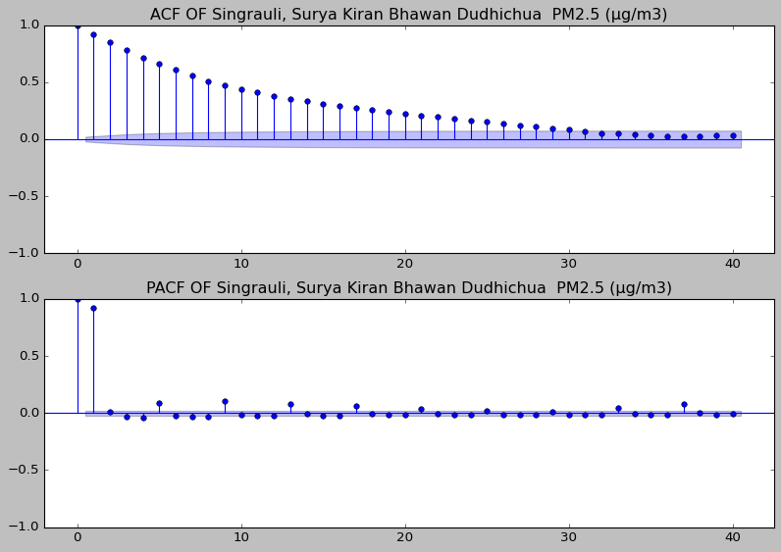

NO(ug/m3)

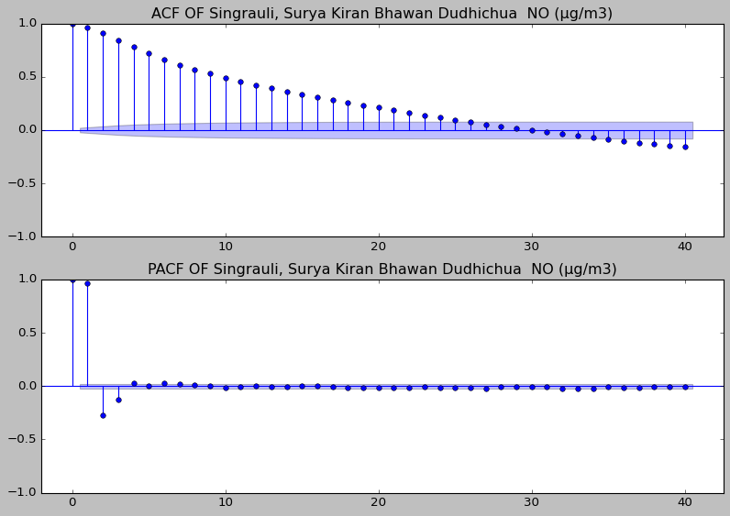

NO2(ug/m3)

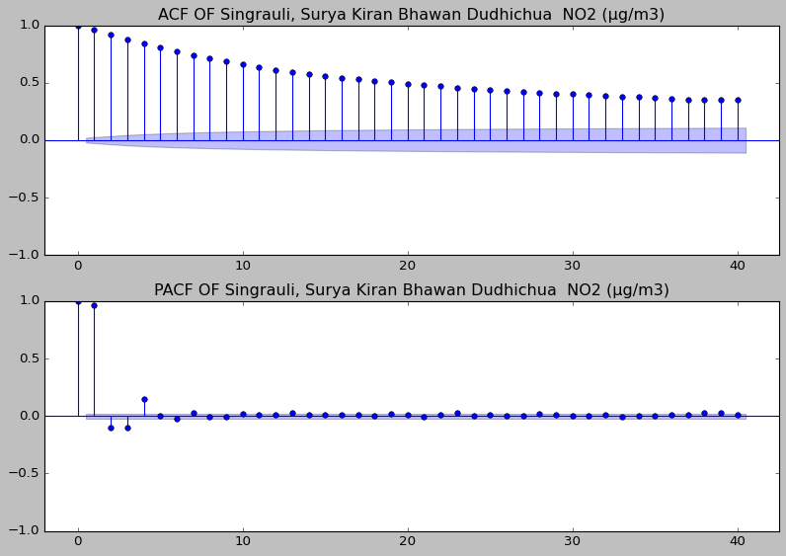

NOX(ppb)

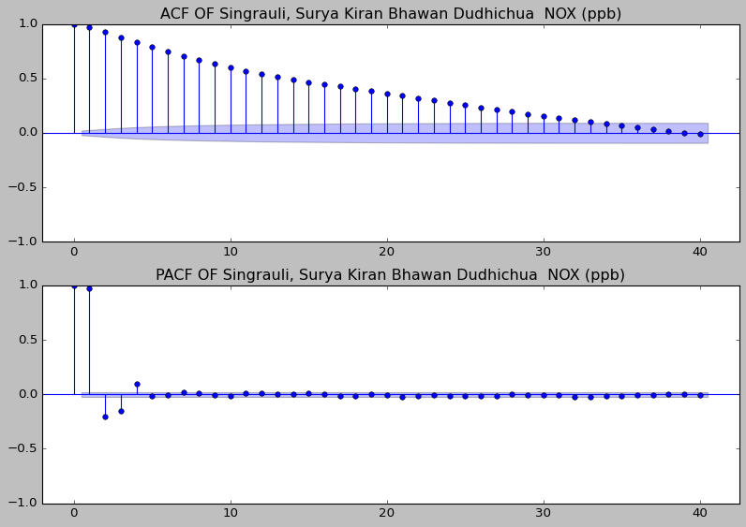

CO(mg/m3)

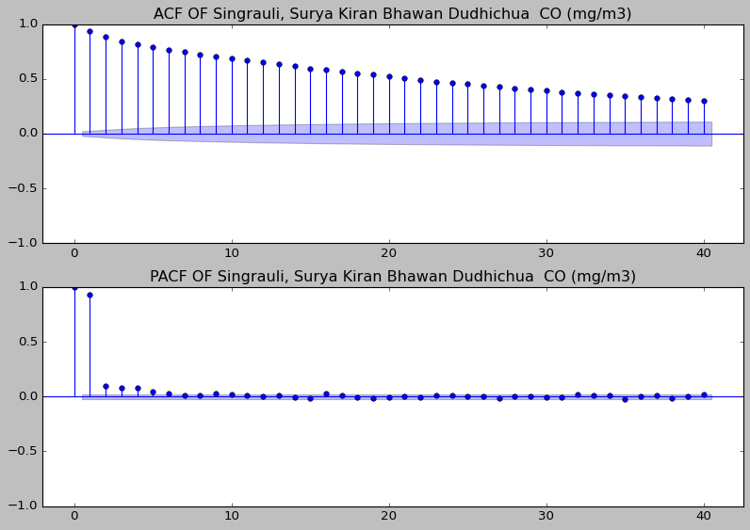

SO2(ug/m3)

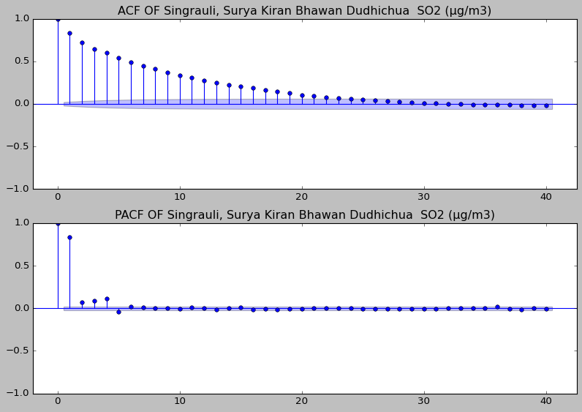

NH3(ug/m3)



Ozone(ug/m3)

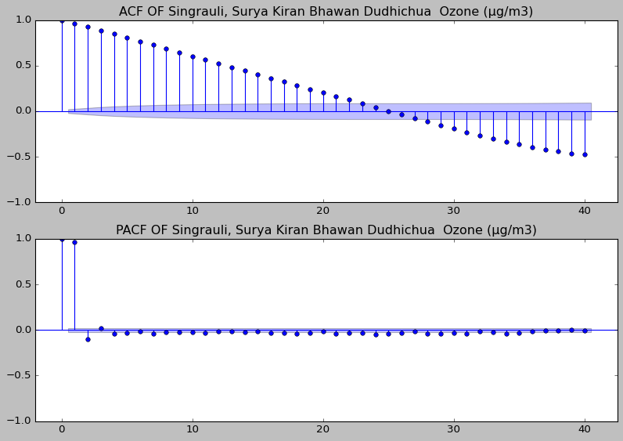

Benzene(ug/m3)

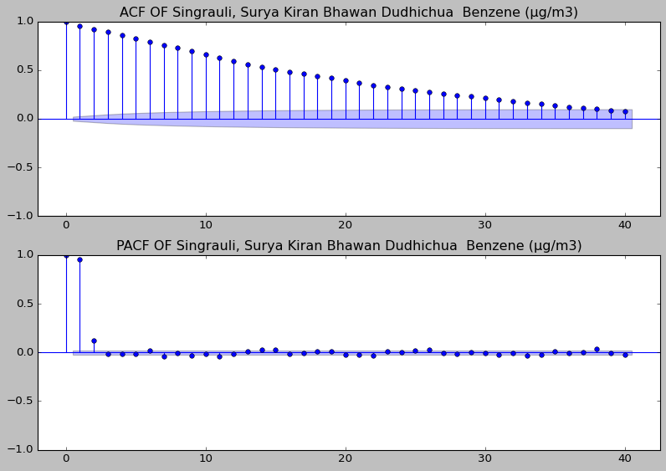

The ACF plots are exponentially decreasing and PACF plots have only some significant signals close to 1, which suggest that the time series should be modelled using auto-regressive model.

lags=[1,1,3,4,4,4,4,5,2,2]

**Auto-regressive Models**

**PM10**

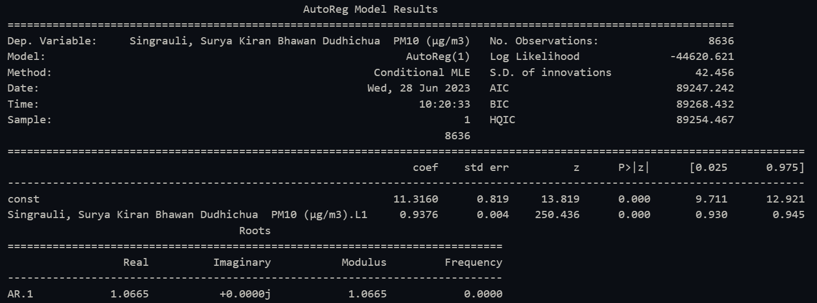

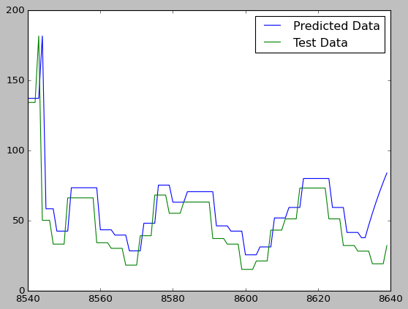

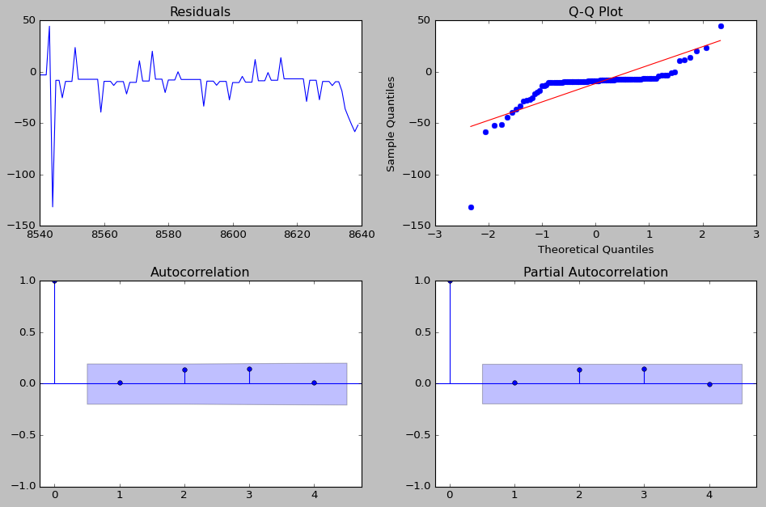

**PM2.5**

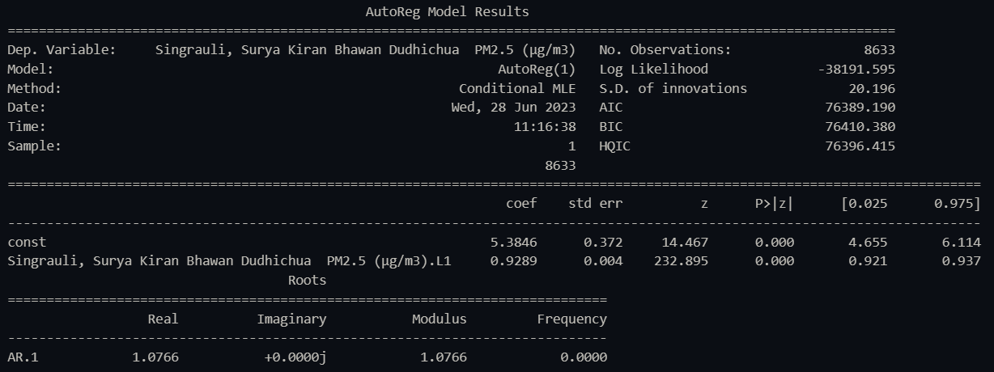

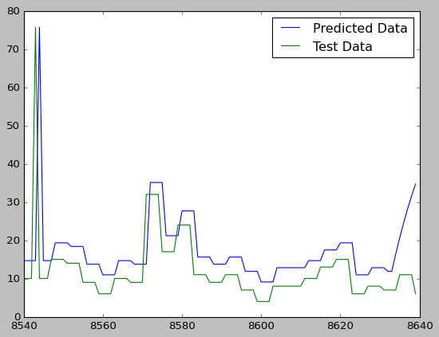

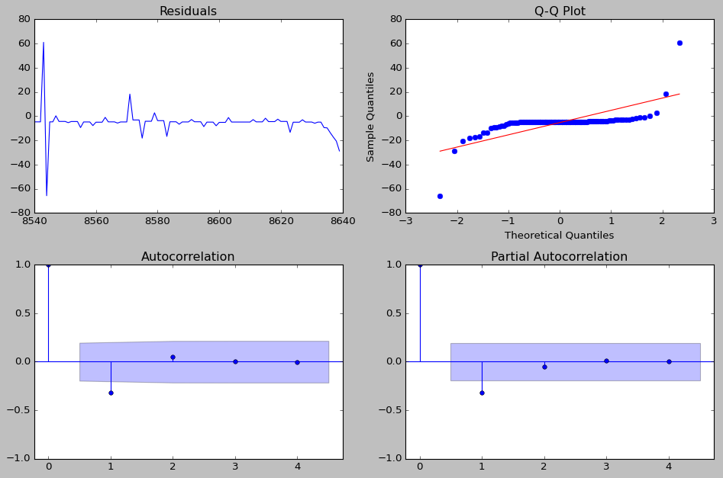

**NO**

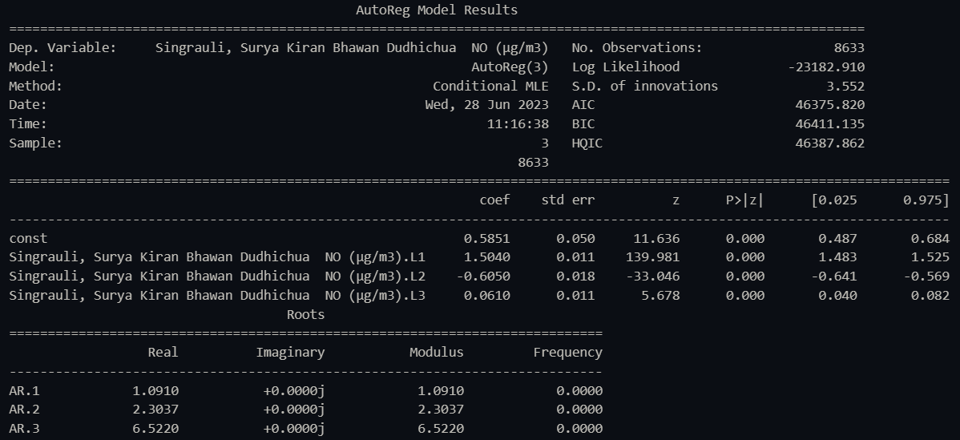

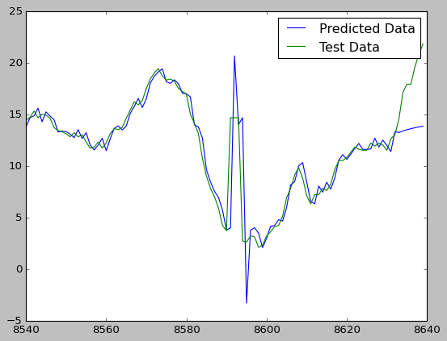

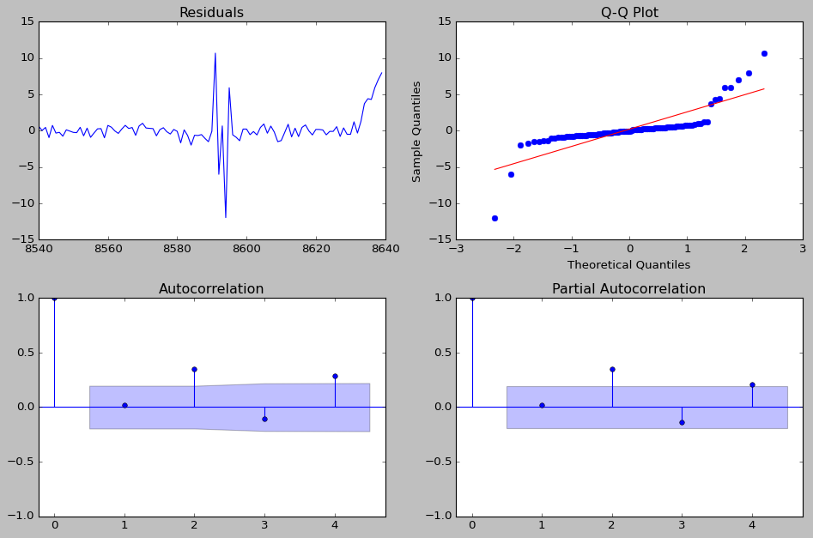

**NO2**

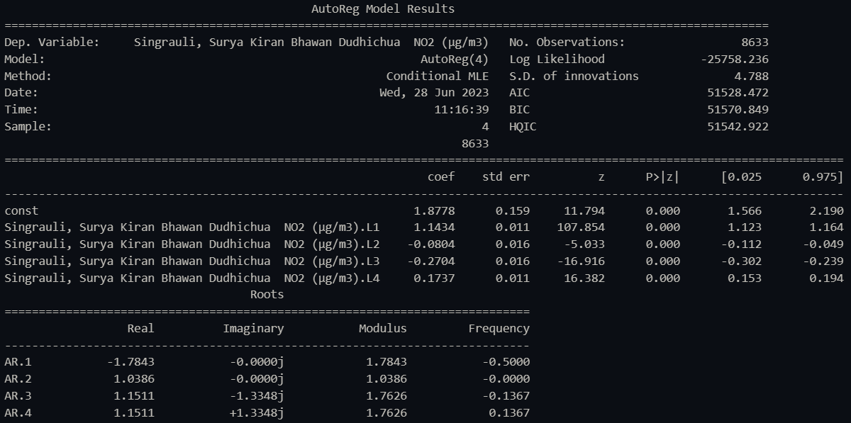

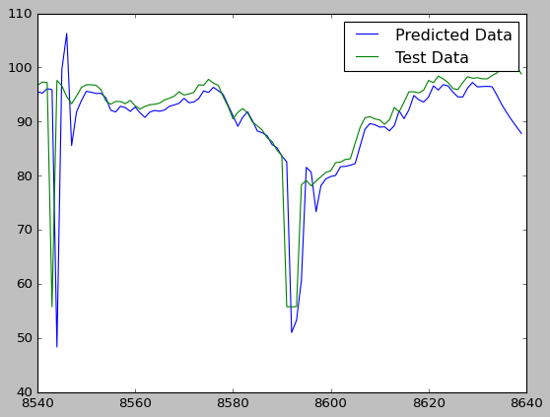

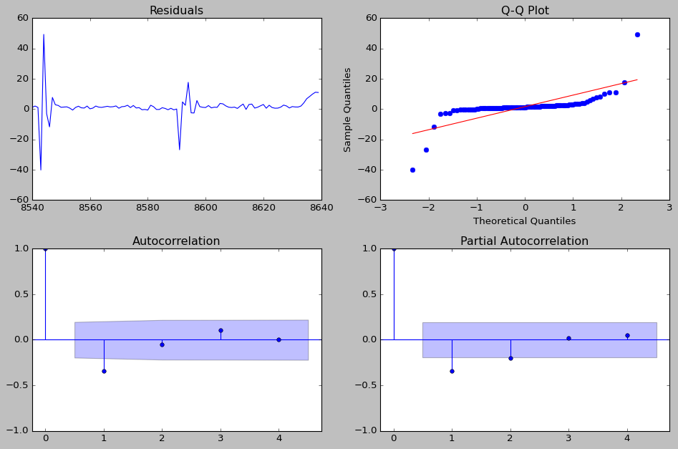

**NOX**

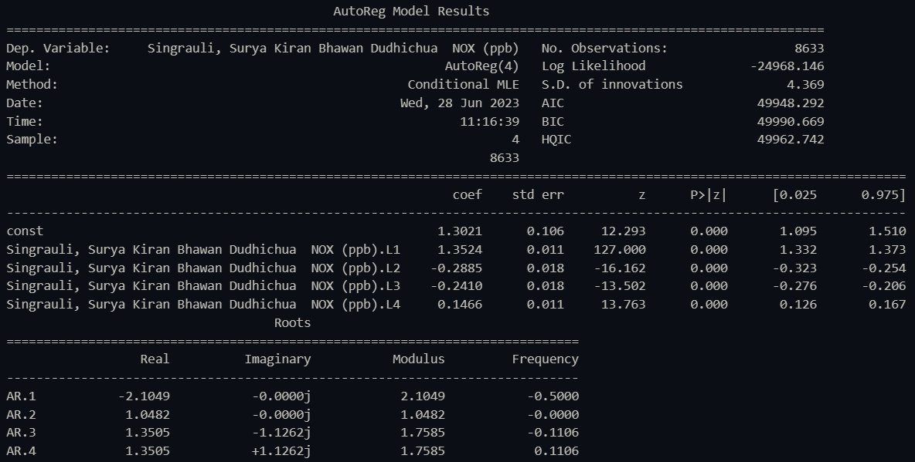

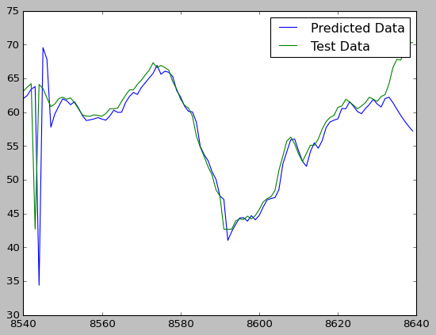

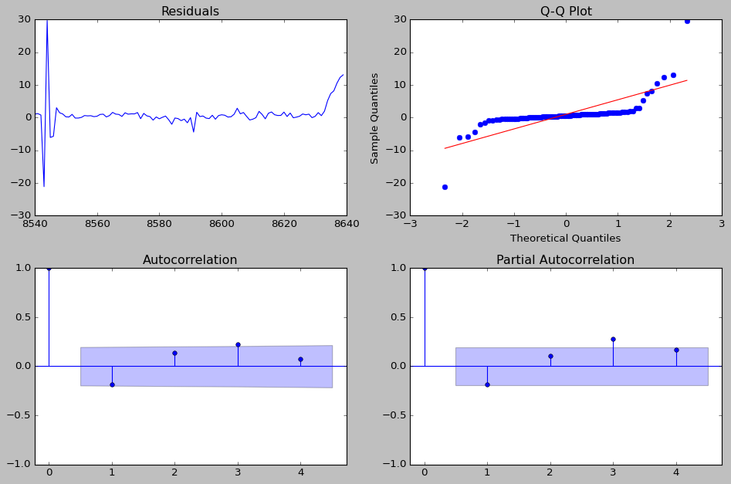

**CO**

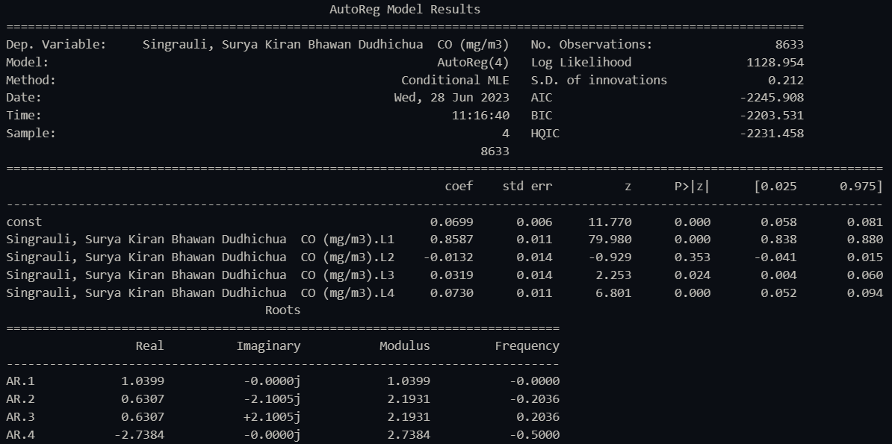

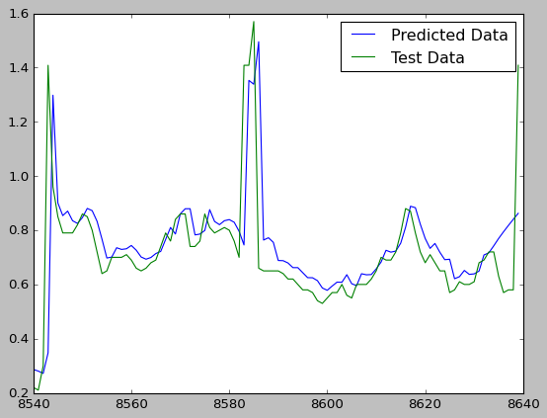

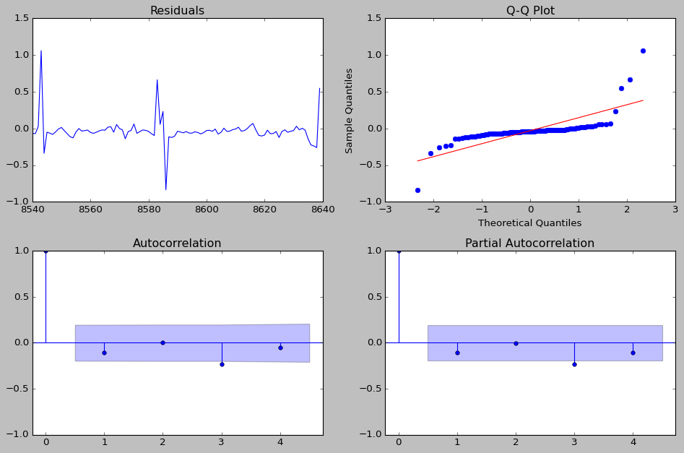

**SO2**

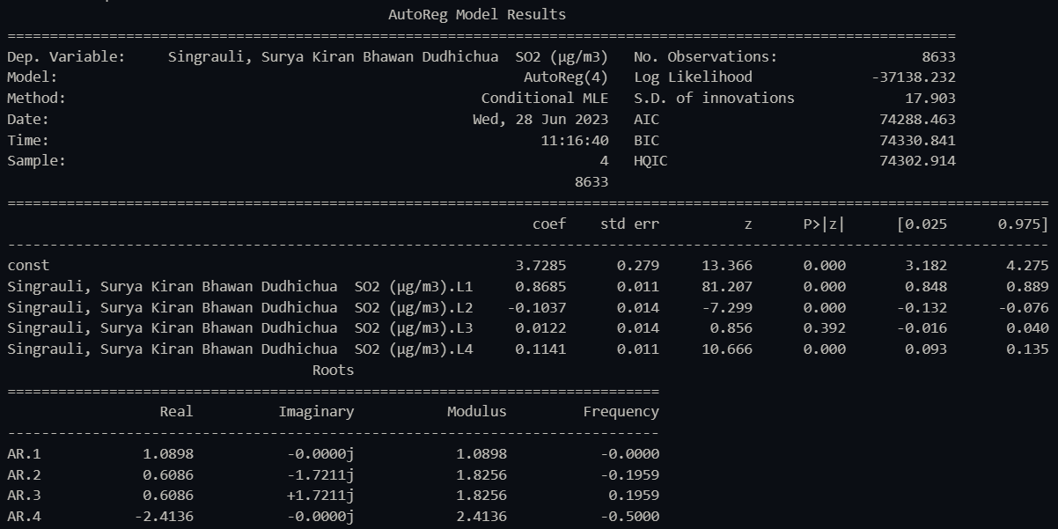

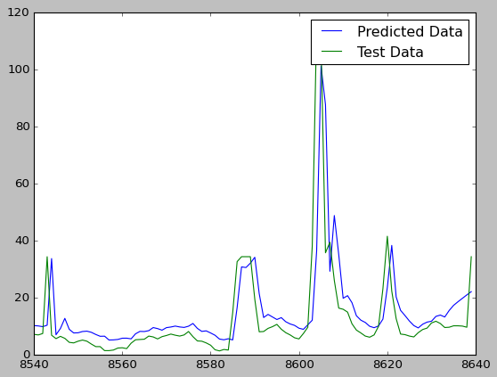

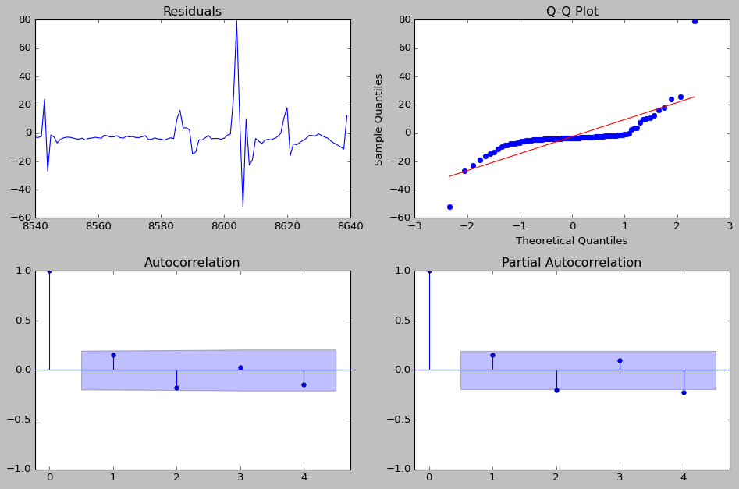

**NH3**

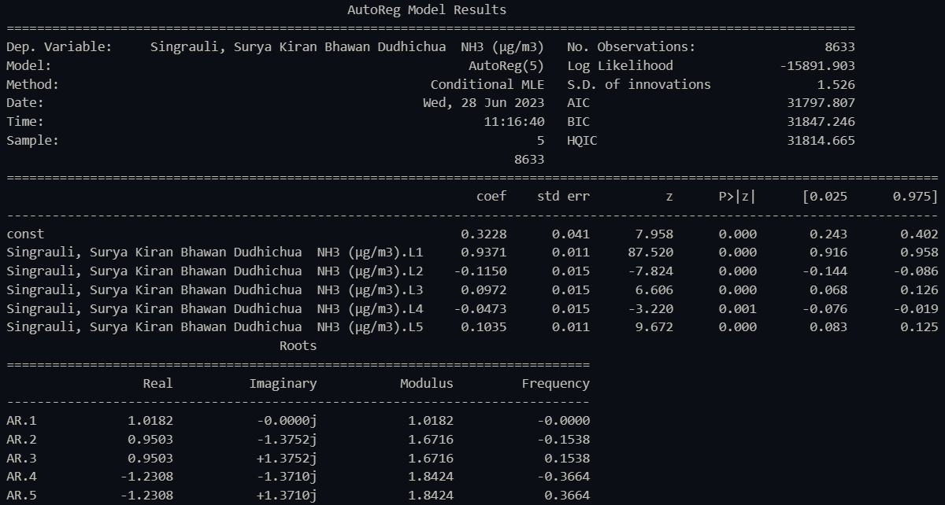

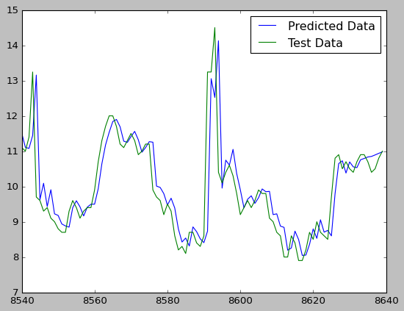

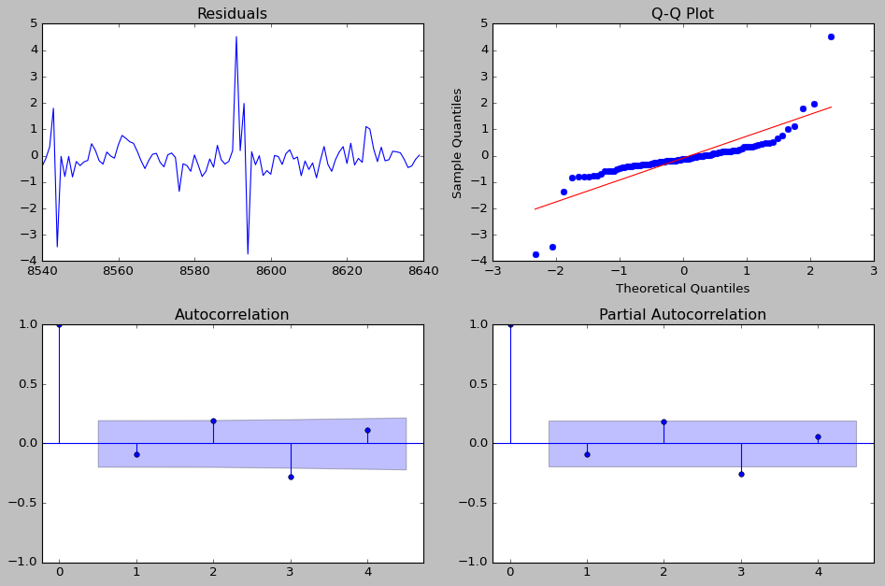

**Ozone**

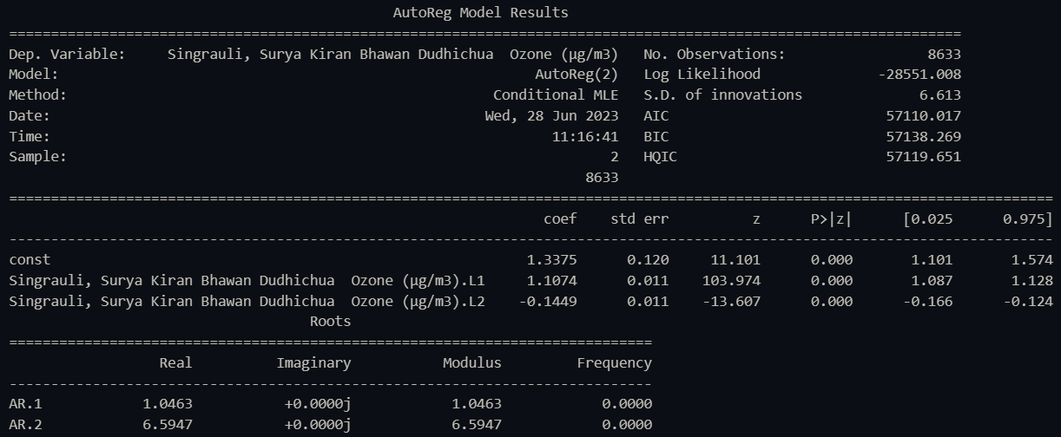

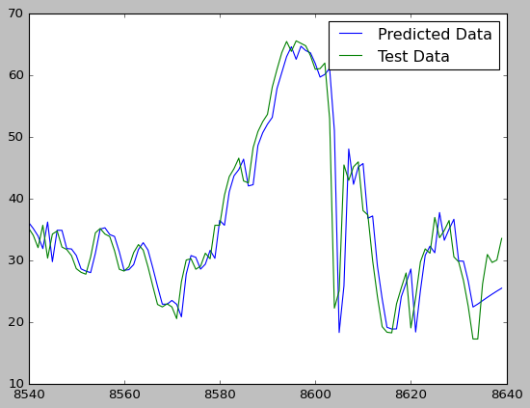

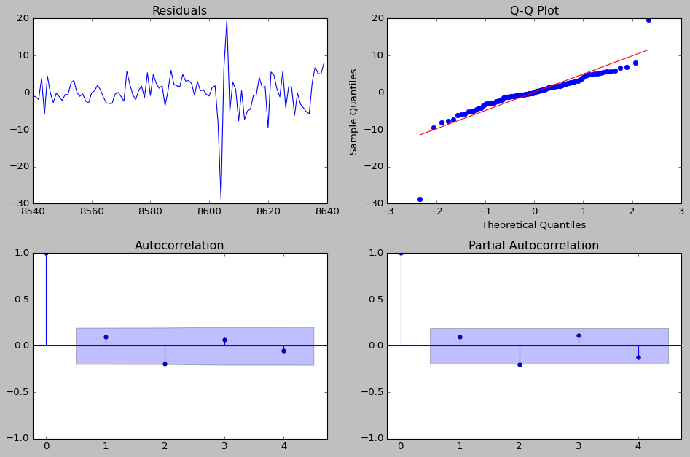

**Benzene**

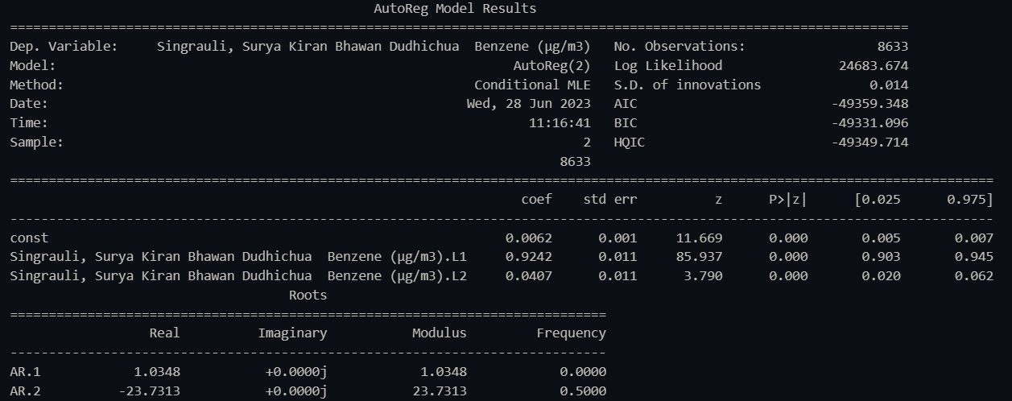

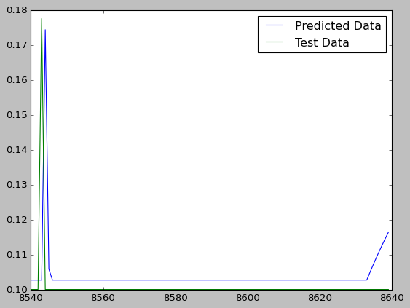

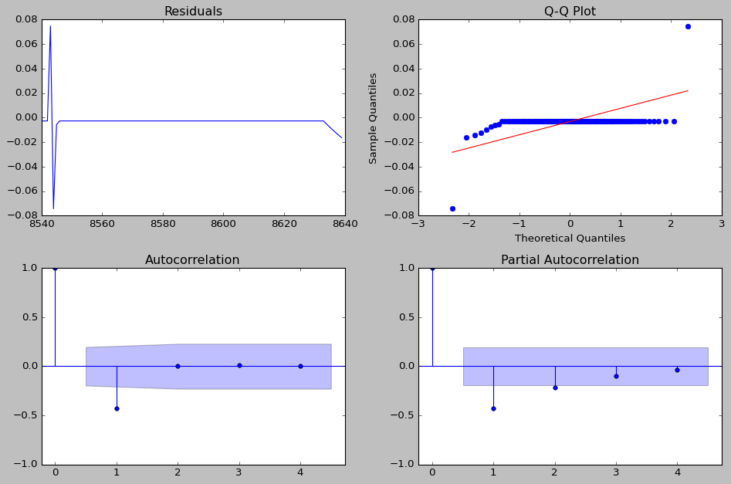

The QQ plot does not follow the straight line, which leads to the conclusion that the distribution plots deviate from normality. This can be verified by plotting the various distribution plots.

**DISTRIBUTION PLOTS**

**PM10**

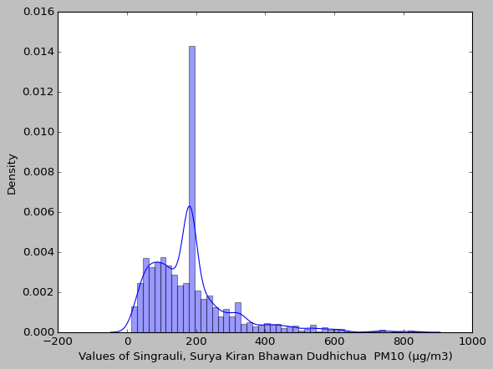

**PM2.5**

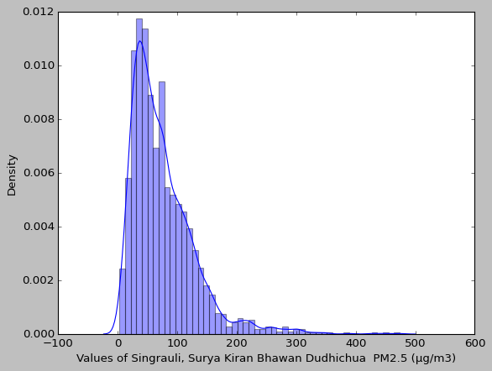

**NO**

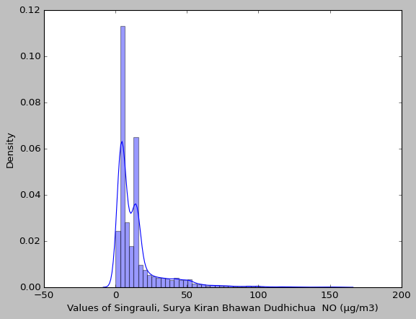

**NO2**

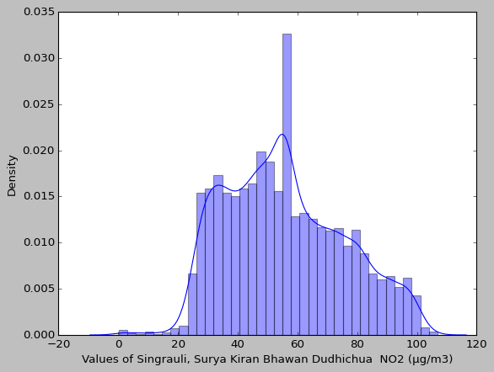

**NOX**

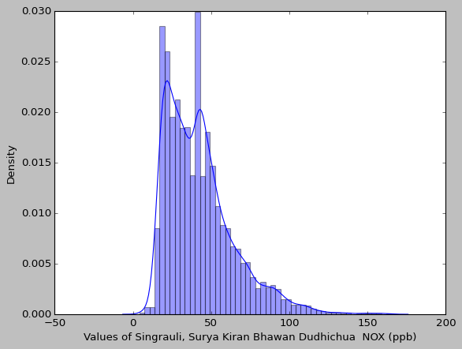

**CO**

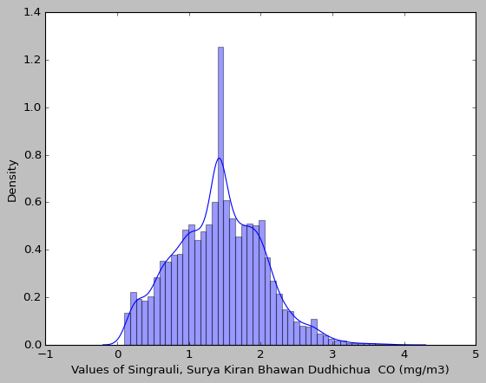

**SO2**

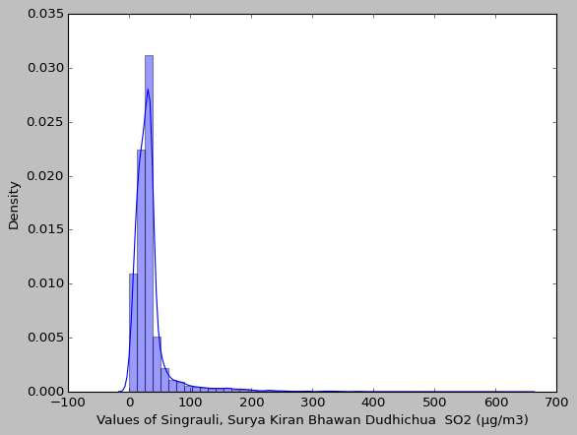

**NH3**

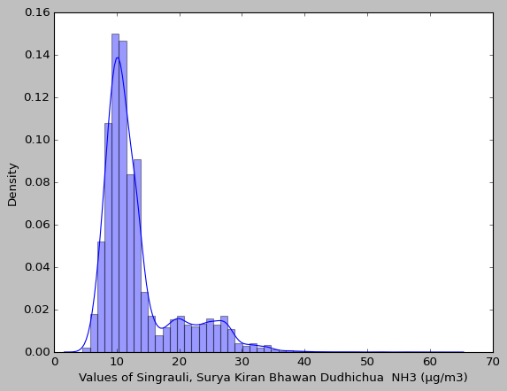

**Ozone**

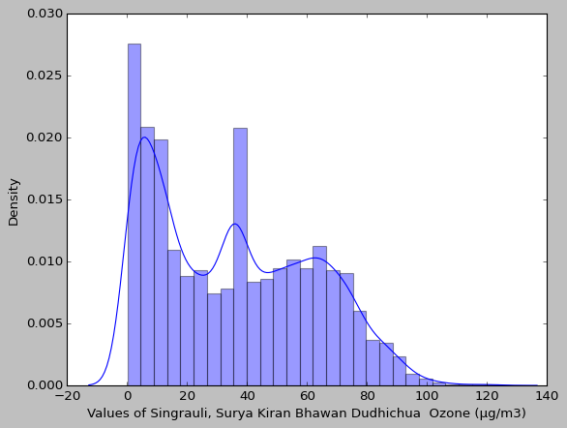

**Benzene**

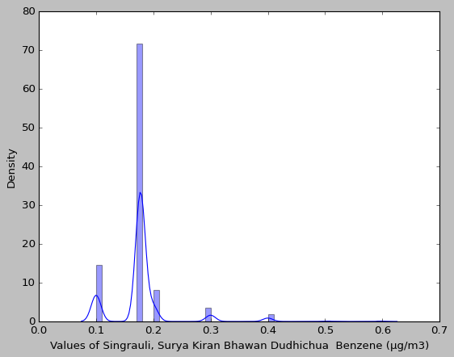

**INTERPOLATION**

**PM10**

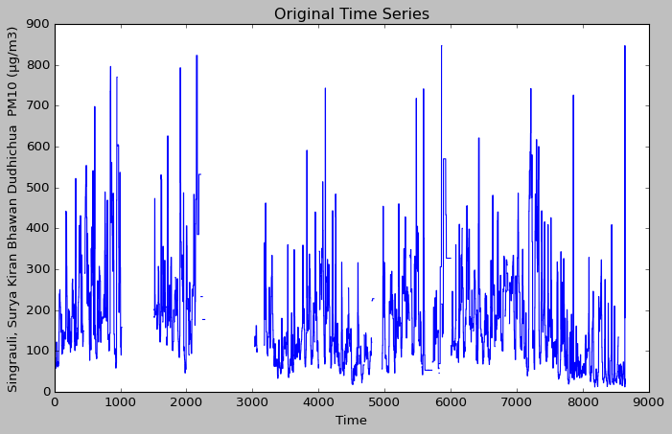

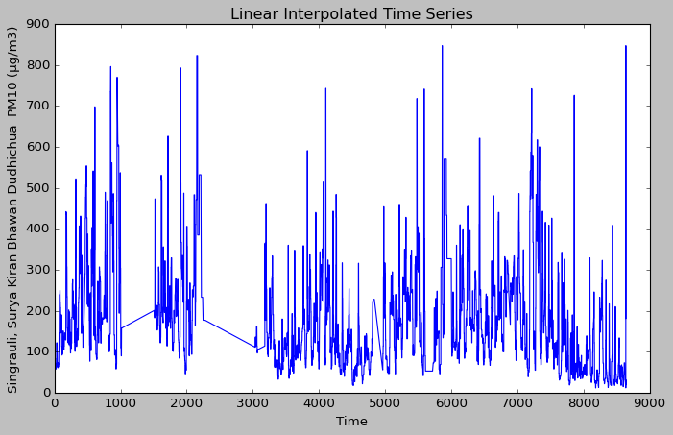

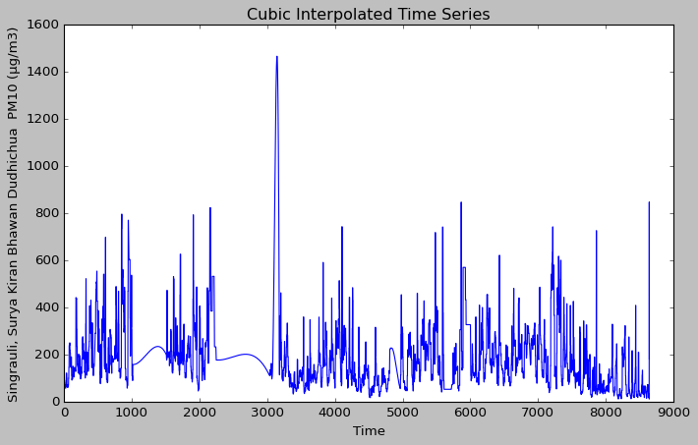

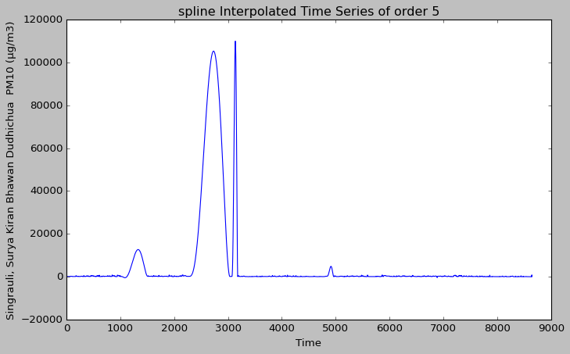

**PM2.5**

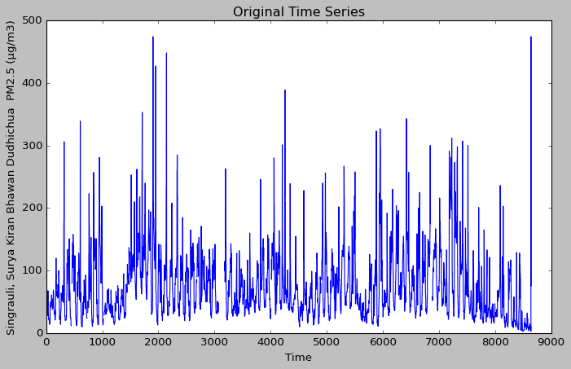

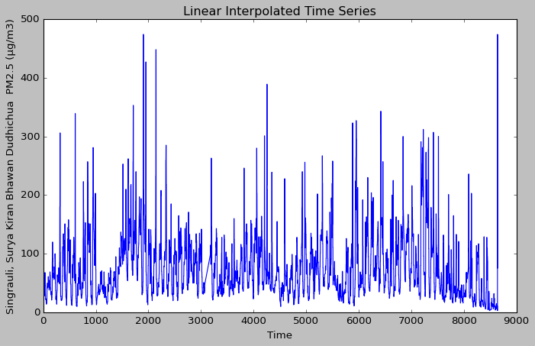

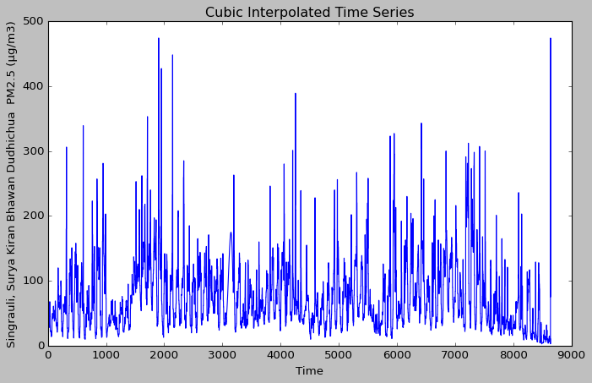

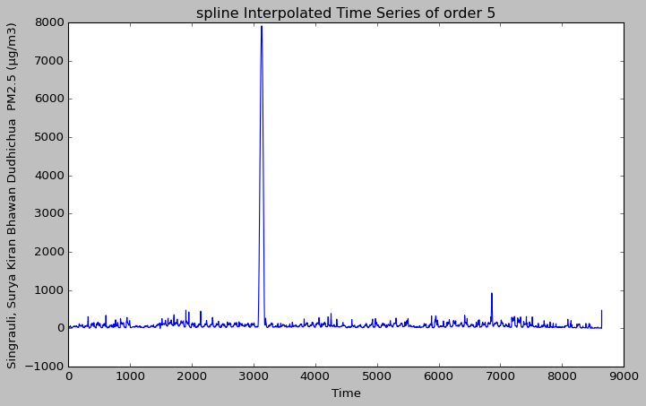

NO

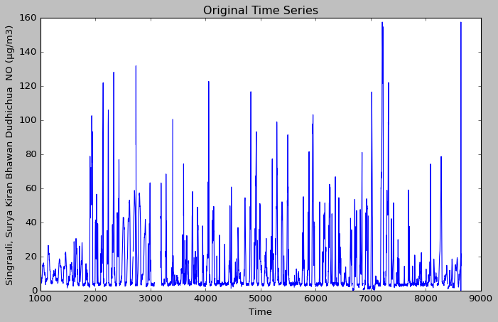

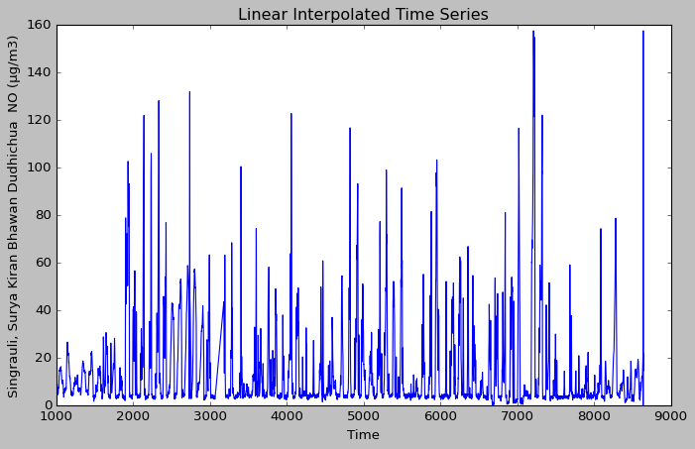

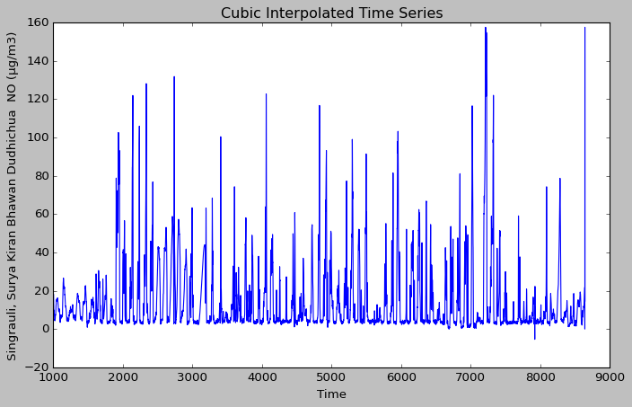

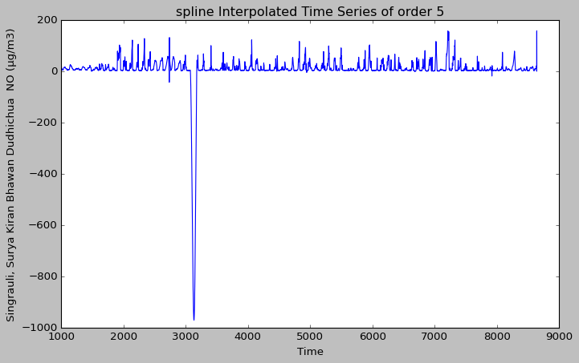

**NO2**

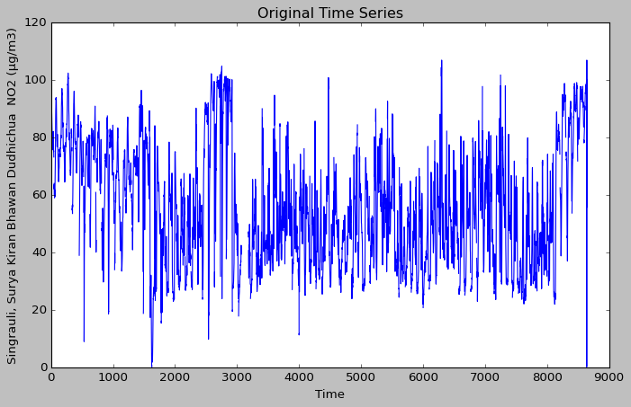

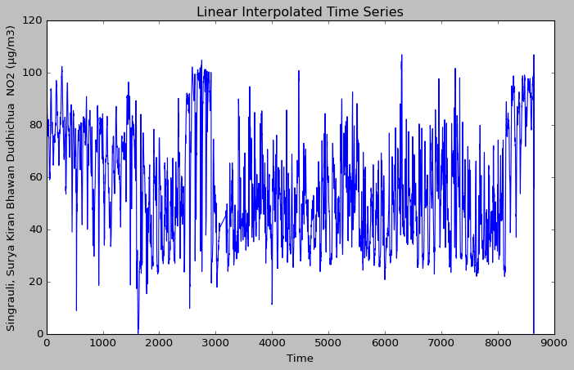

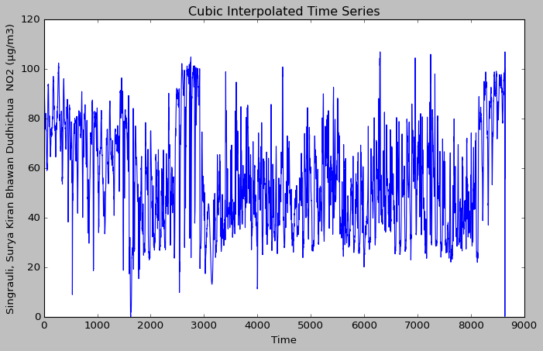

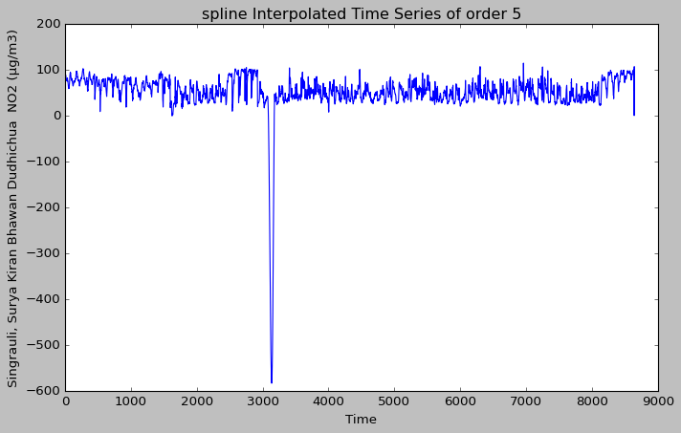

**NOX**

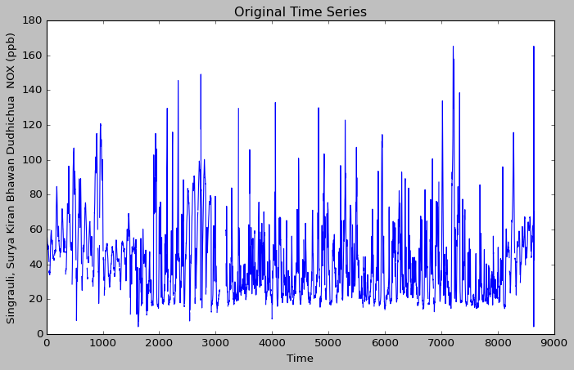

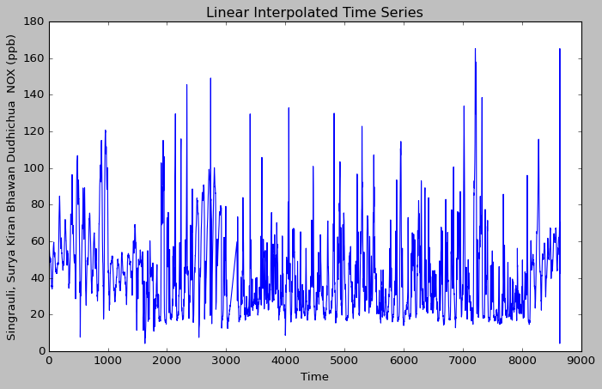

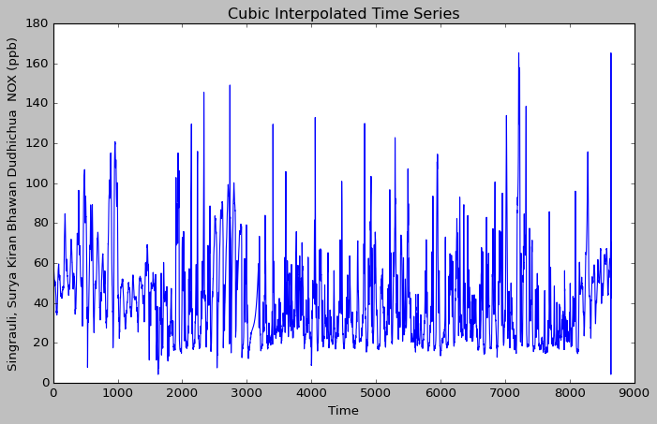

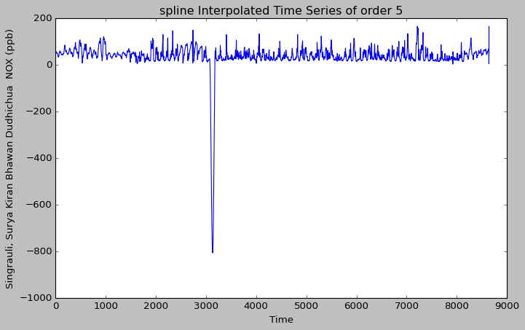

**CO**

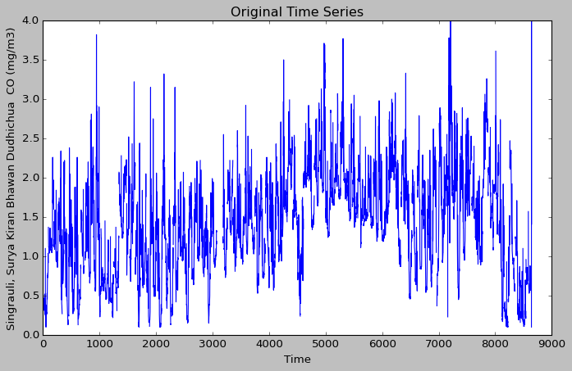

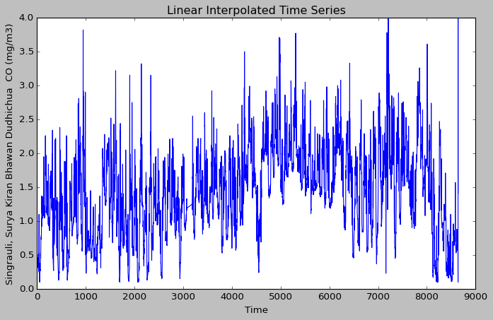

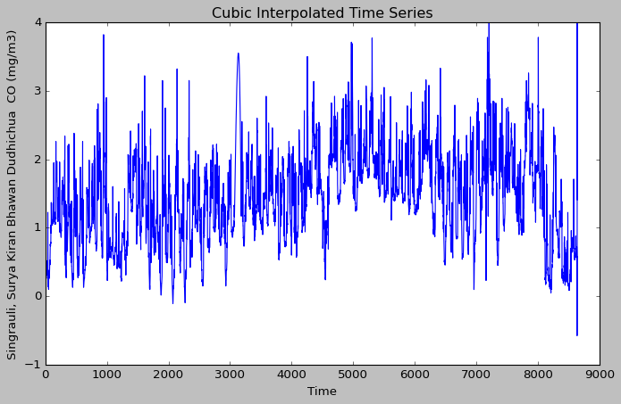

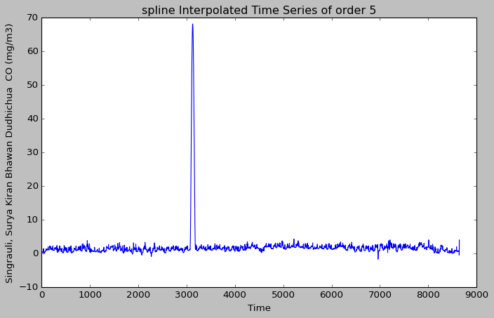

**SO2**

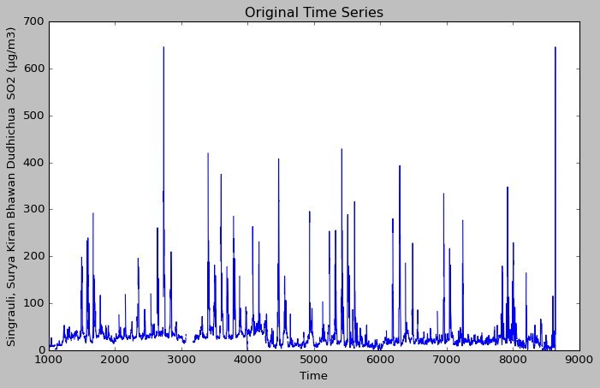

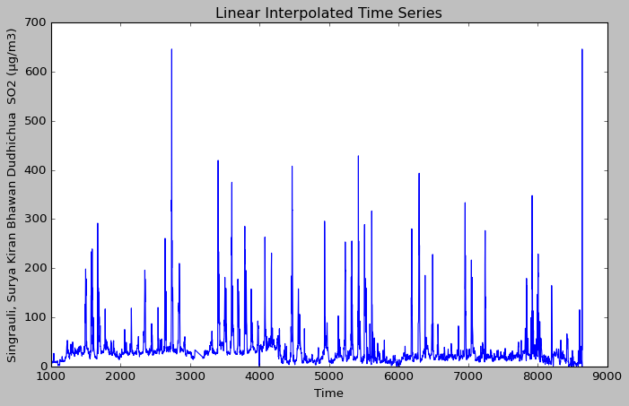

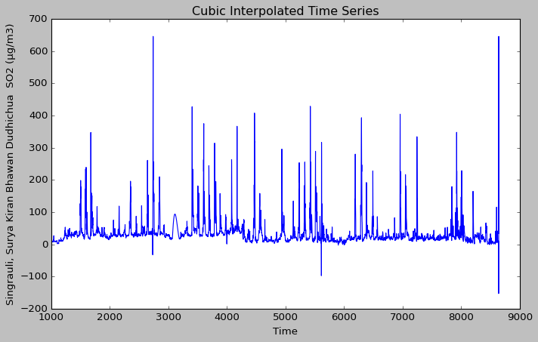

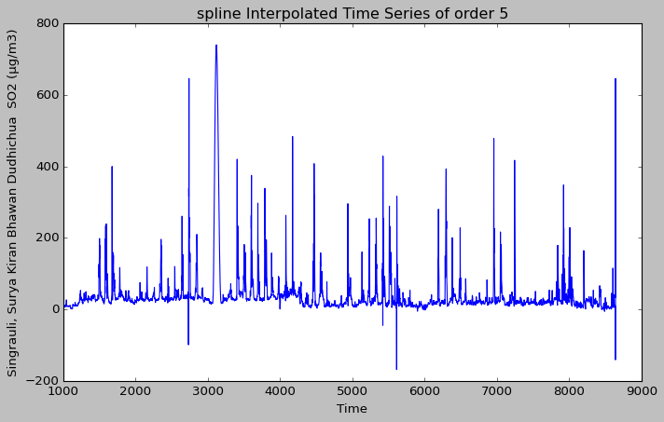

**NH3**

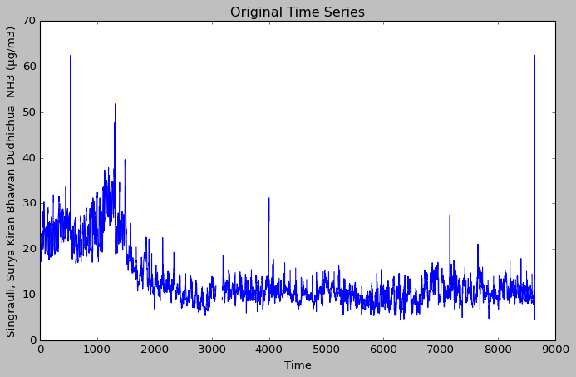

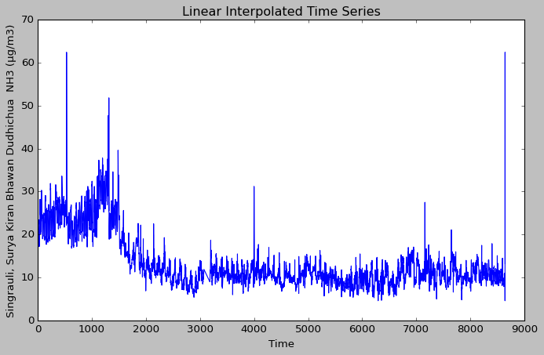

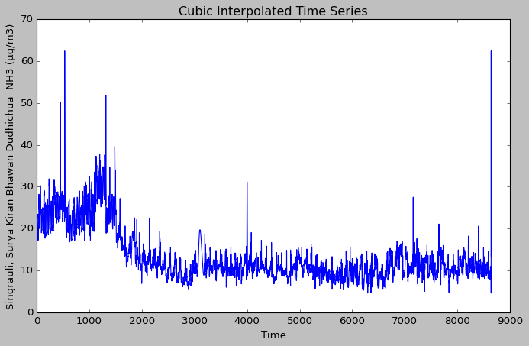

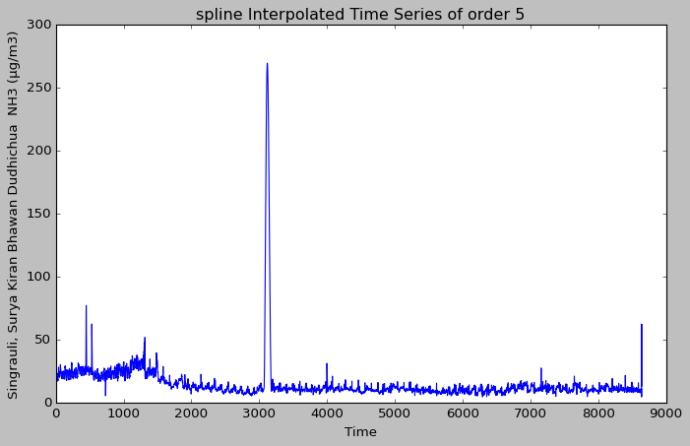

**Ozone**

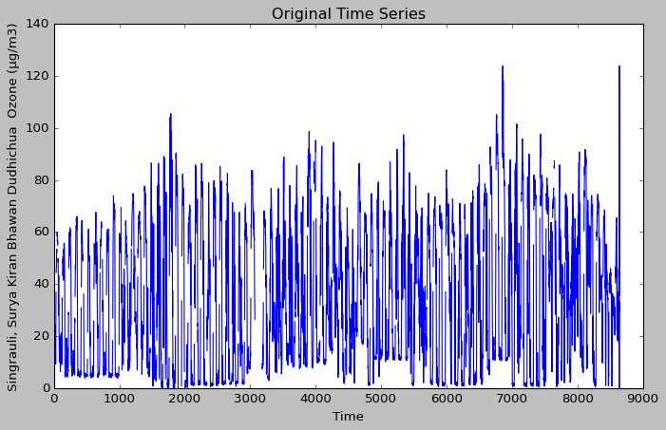

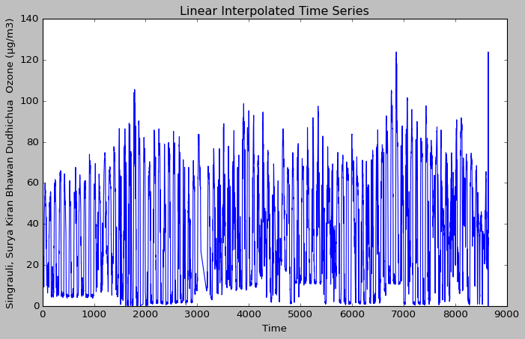

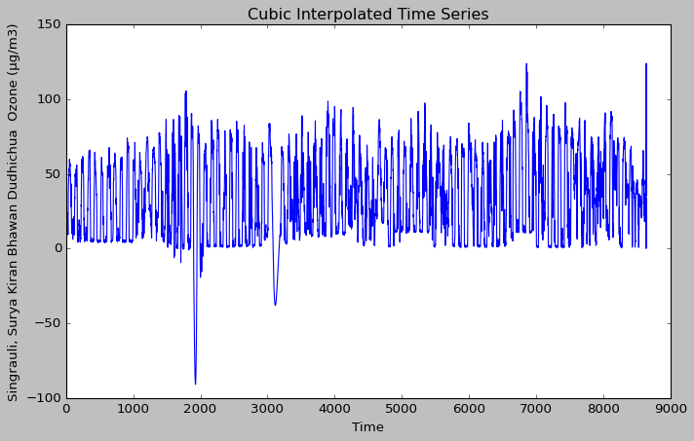

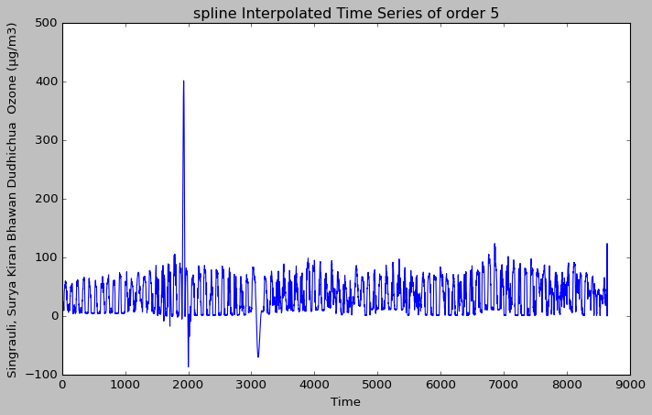

**Benzene**

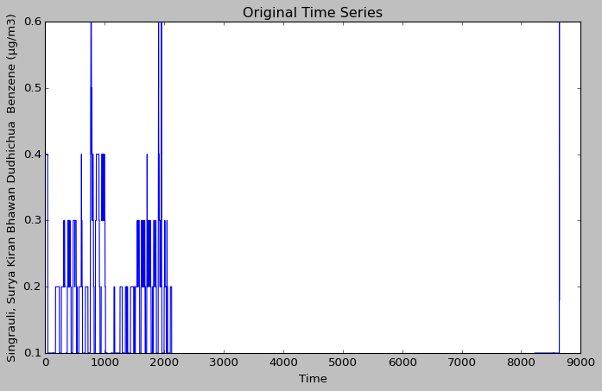

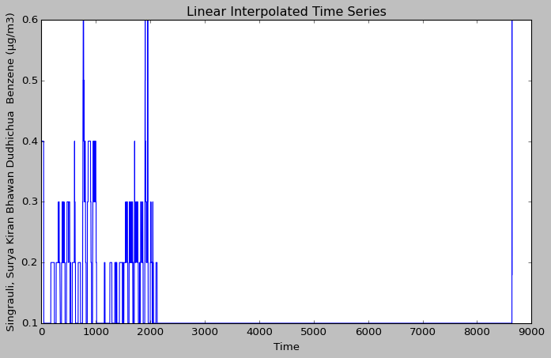

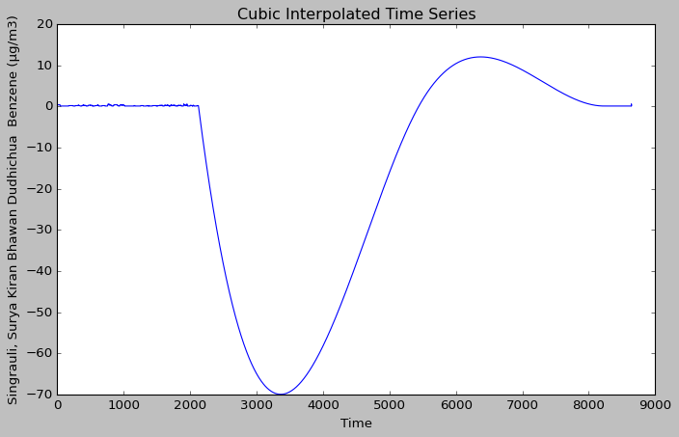

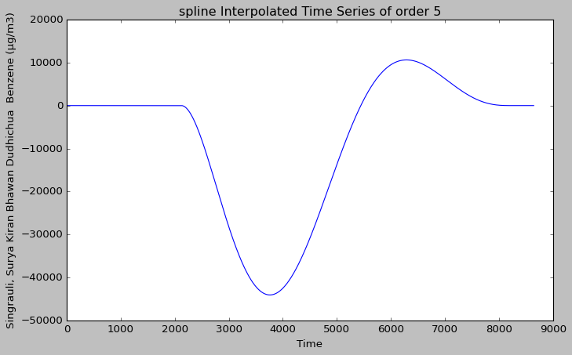

**SEASONALITY AND TREND**

**PM10**

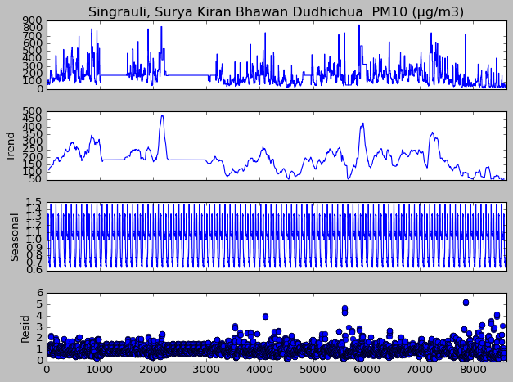

**PM2.5**

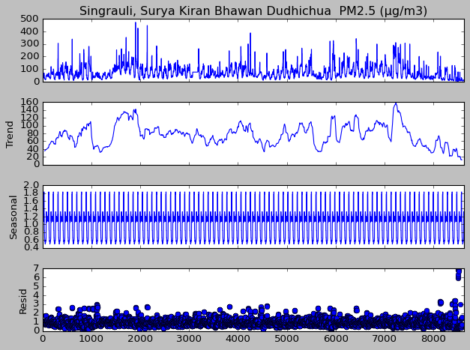

**NO**

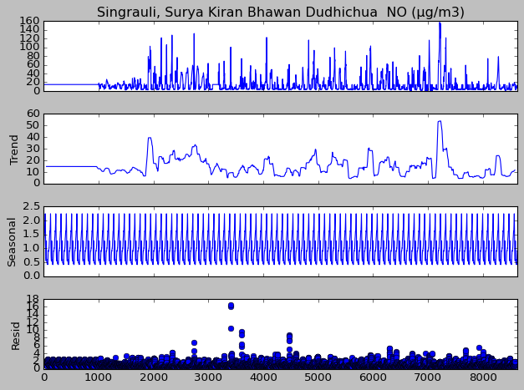

**NO2**

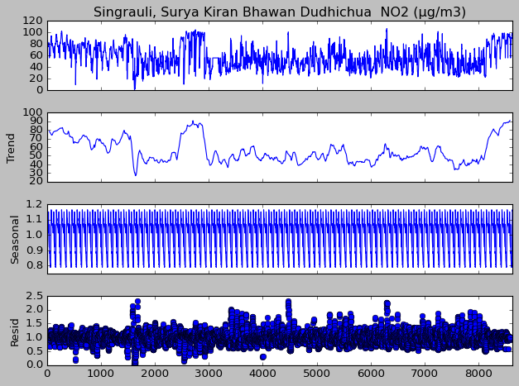

**NOX**

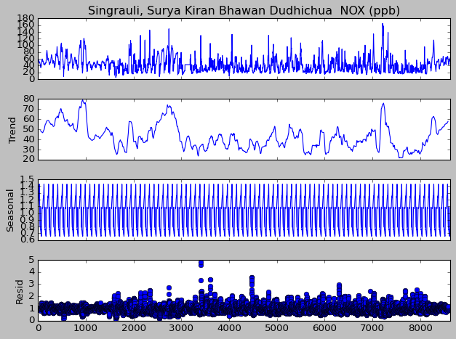

**CO**

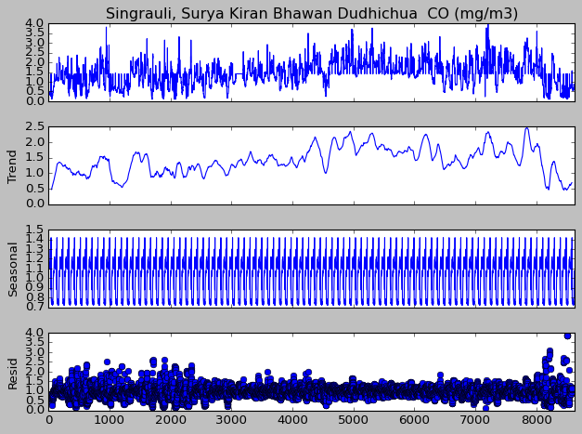

**SO2**

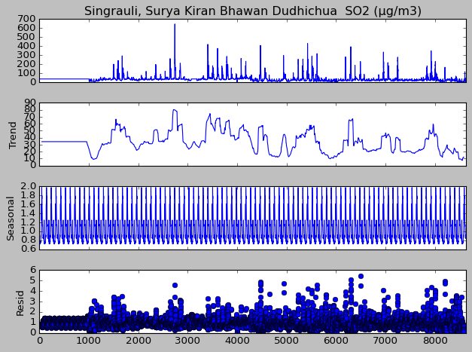

**NH3**

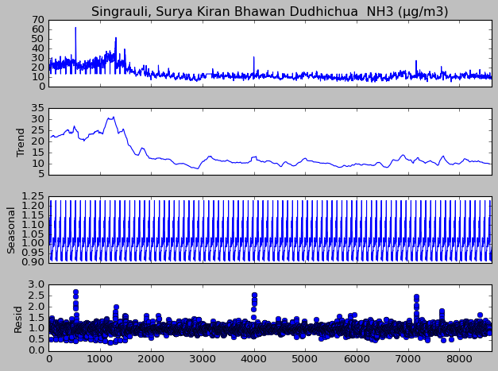

**Ozone**

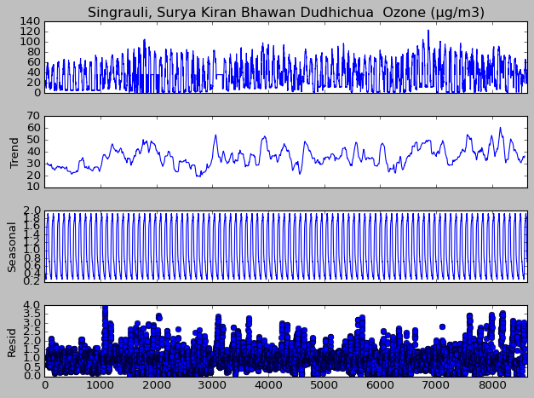

**Benzene**

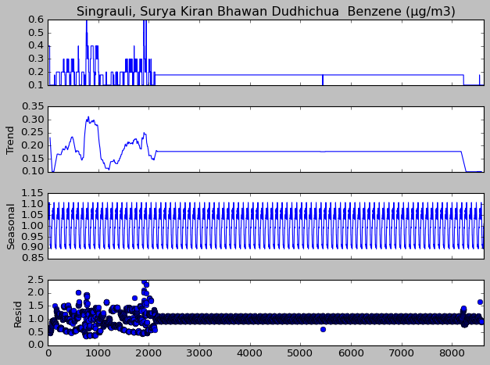

Since the seasonality graph fluctions remain relatively constant over time , it suggests additive seasonality.

The trend appears to be random but the seasonality graph exhibits certian patterns, which means that the time series exhibit recurring patterns or cycles at regular intervals. While it may be challenging to make long-term predictions based on the random trend, the presence of strong seasonality allows for short-term forecasting. Seasonal patterns provide valuable information for forecasting future values within each seasonal cycle. It is useful to decompose the time series into its individual components, such as trend, seasonality, and residual, to better understand their contributions. The random trend suggests focusing on modeling the seasonality component explicitly.

Derived Weights:

* PM10 -> -5.42804567e-36
* PM2.5 -> 3.62422122e-02
* NO -> 3.34382739e-02
* NO2 -> 8.54758284e-03
* NOX -> -1.85622780e-03
* CO -> 9.00368457e-01
* SO2 -> -2.68874111e-03
* NH3 -> -1.98786316e-03
* Ozone -> -1.48564736e-02
* Benzene -> 1.41680042e-05

**Plot of total pollution calculated through weighted pollutants**

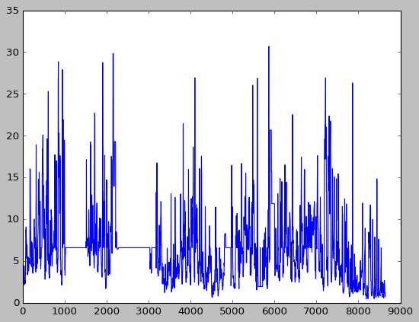

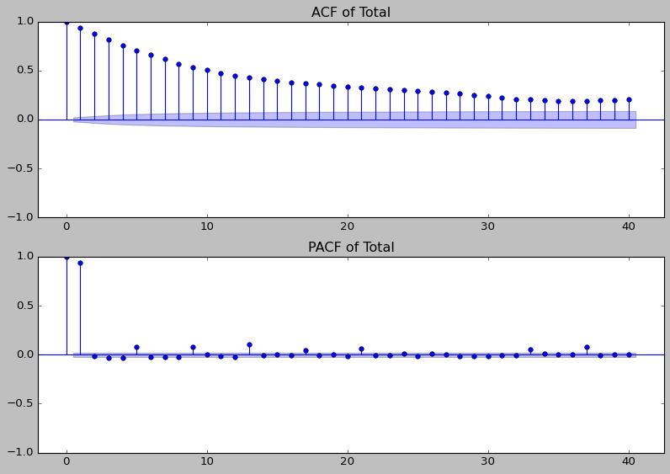

**Plot of predicted total pollution**

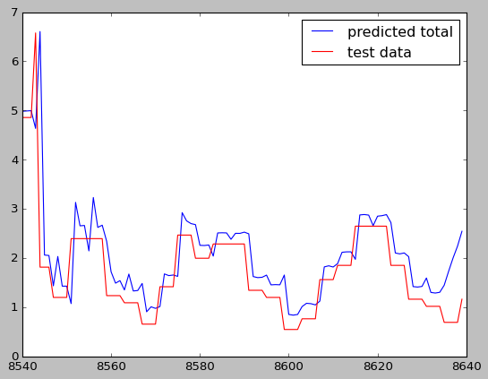

Root mean squared error : 0.720774

Next I plotted pollution value for each day for all 90 days and considered the plots in which the original data was not missing. Observing from these plots, usually level of pollution is low at the beginning hours of the day then reaches a minima. Then the level of pollution increases at peaks at around 9pm.

Some plots of daily pollution:

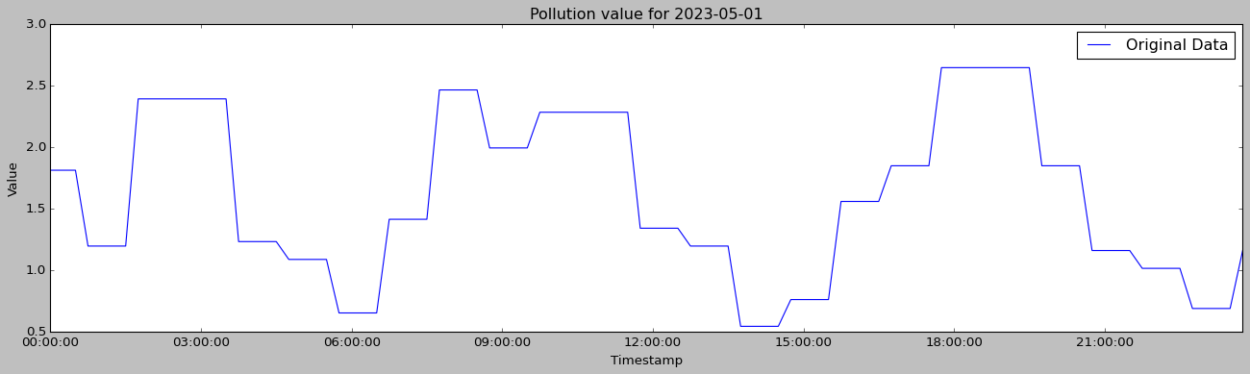

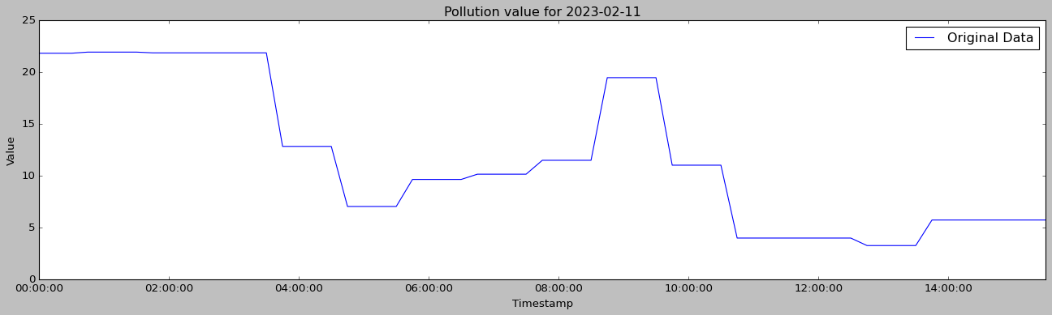



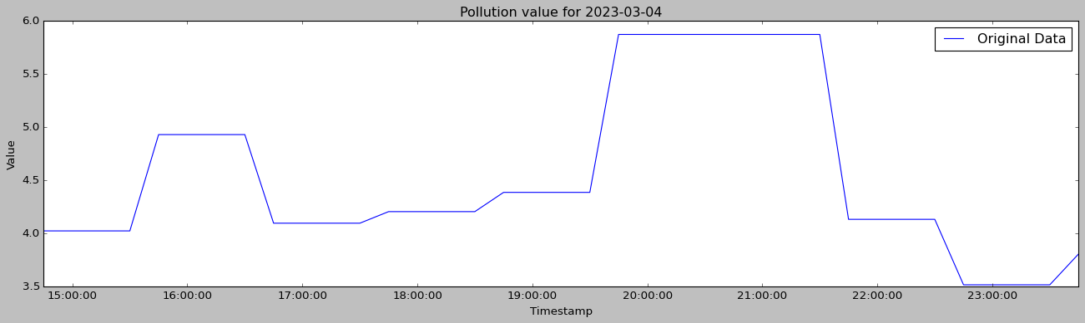

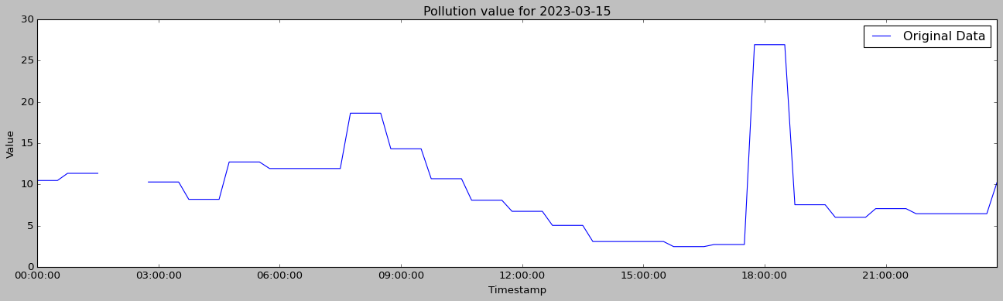

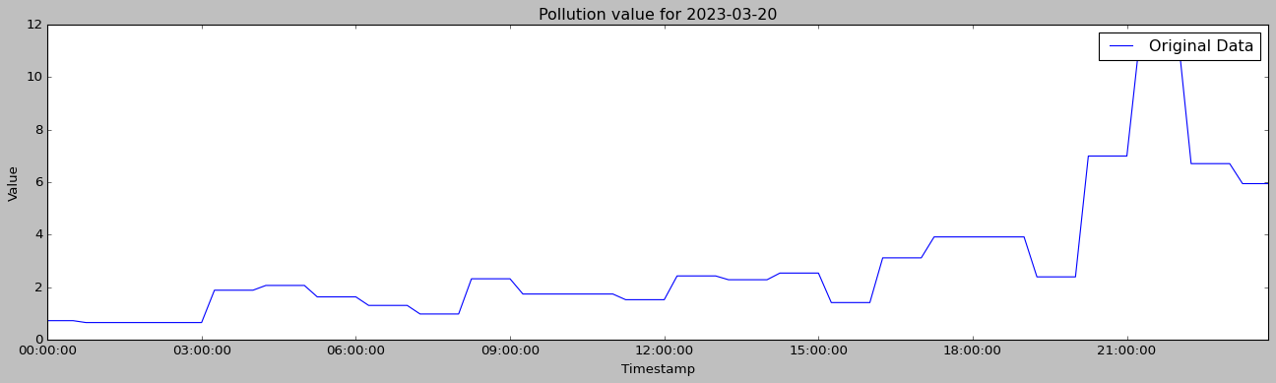





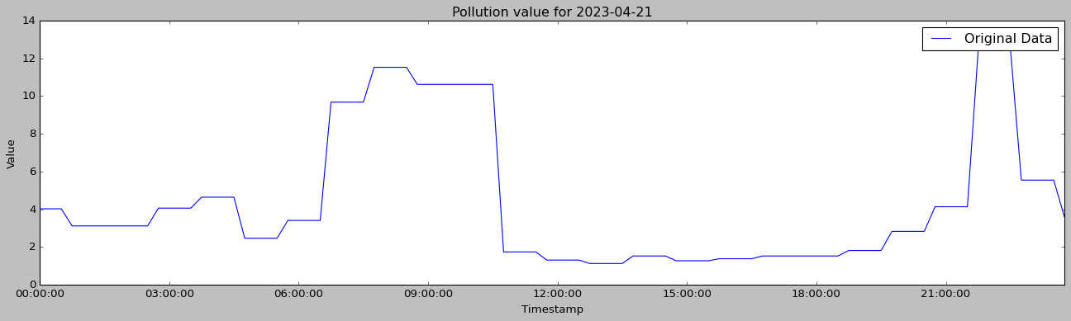



**Parametric curve fitting**

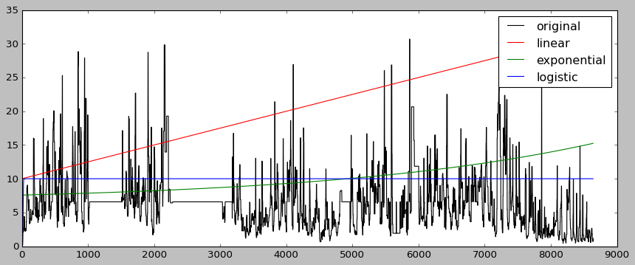

Here parametric curve fitting is giving poor outputs so it will not be beneficial to use it.

**Non-parametric curve fitting**

**Decision Tree Regression**

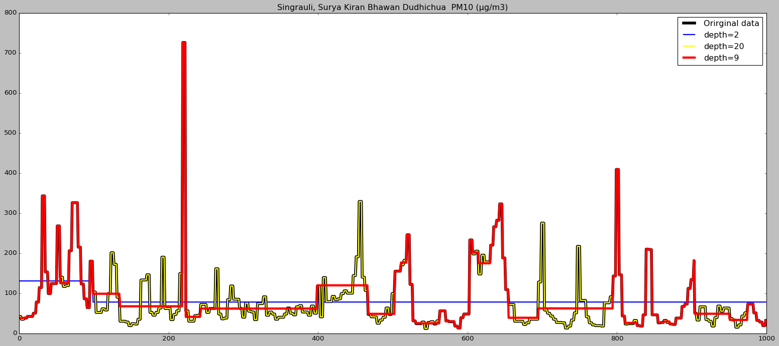

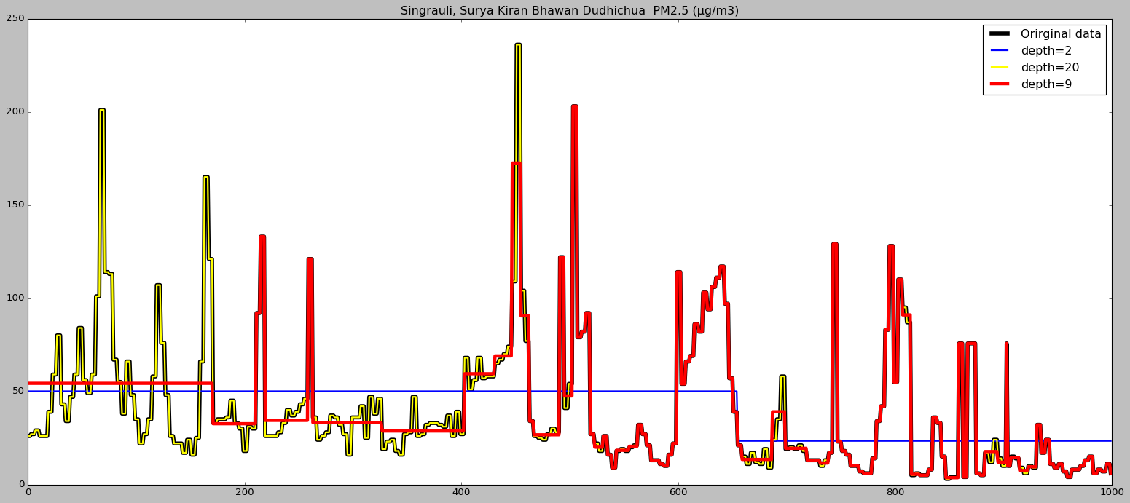

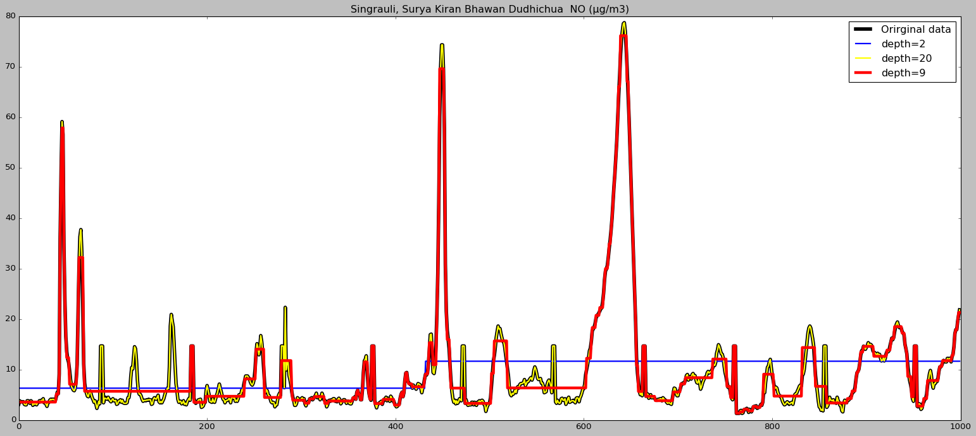

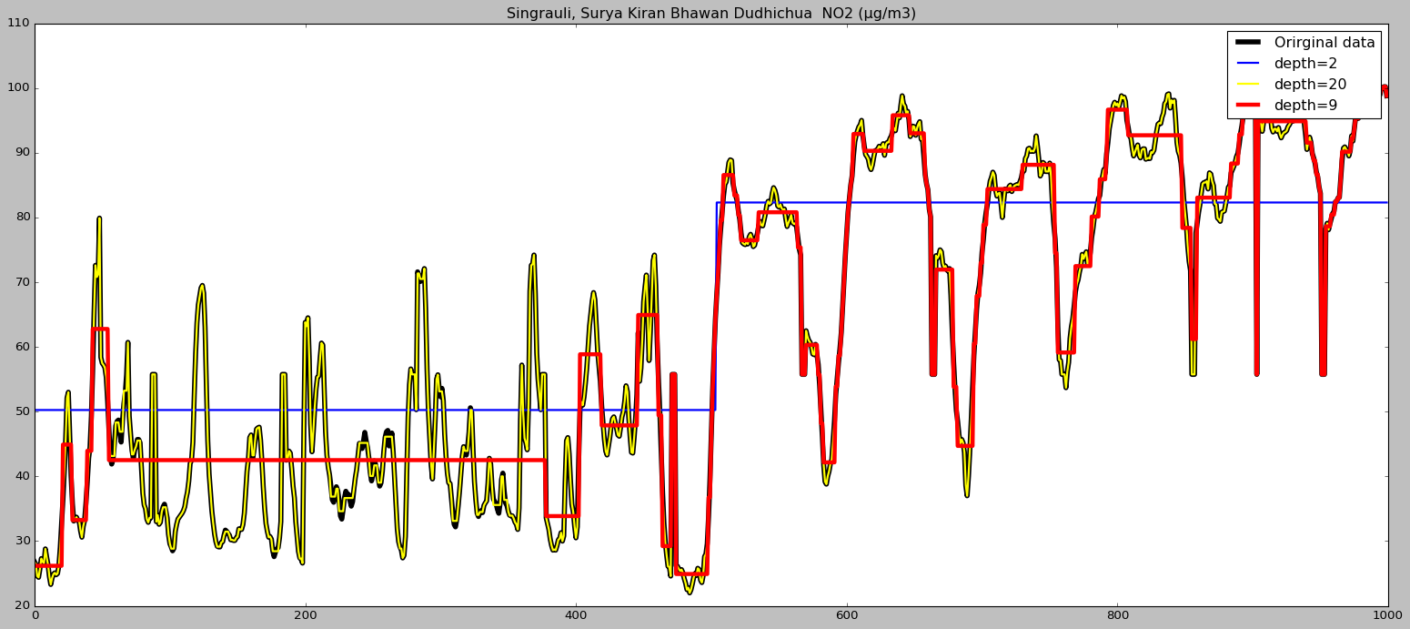

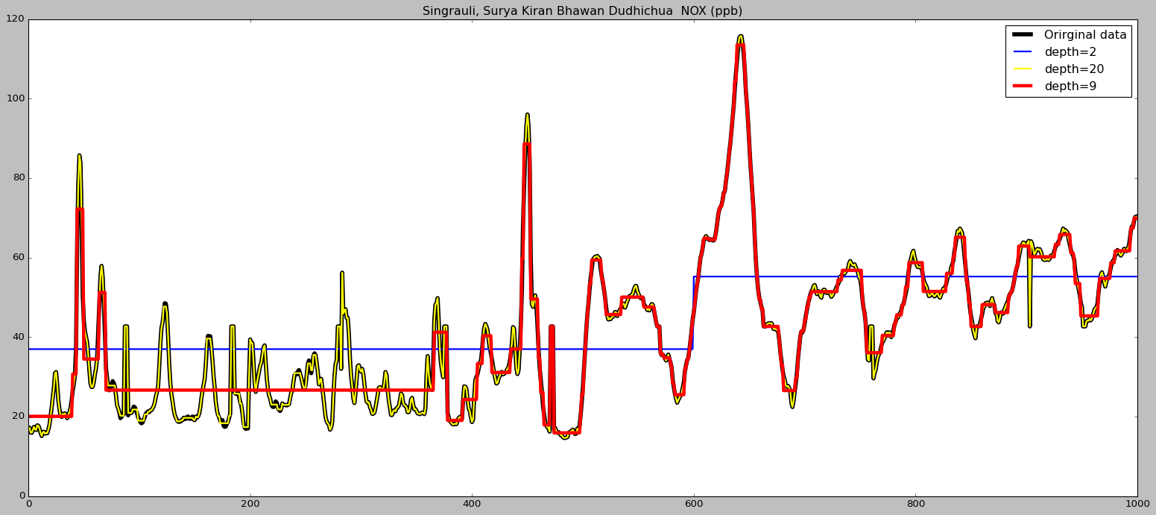

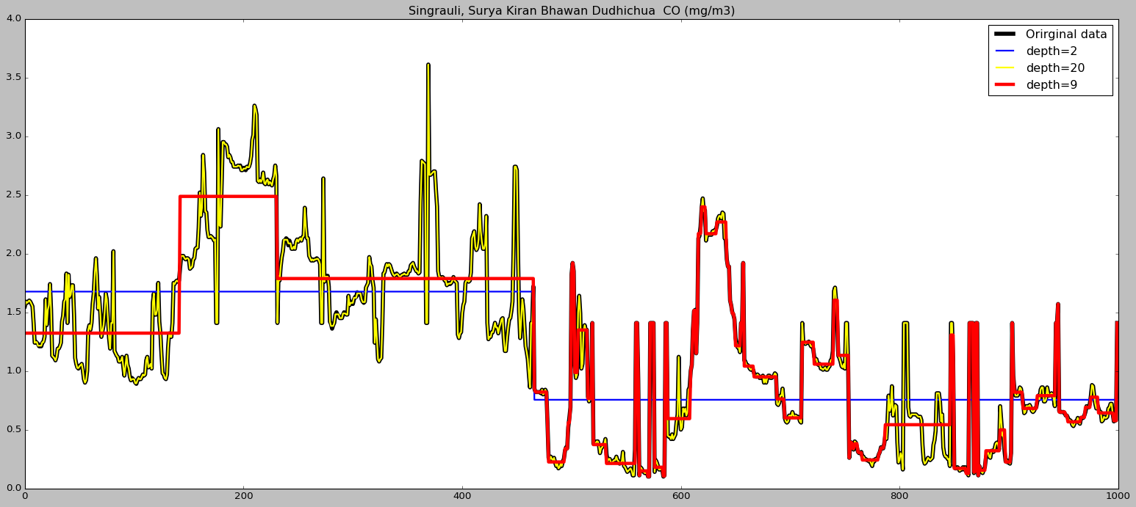

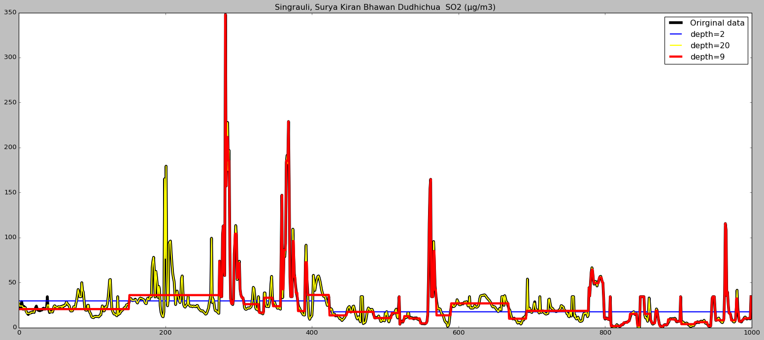

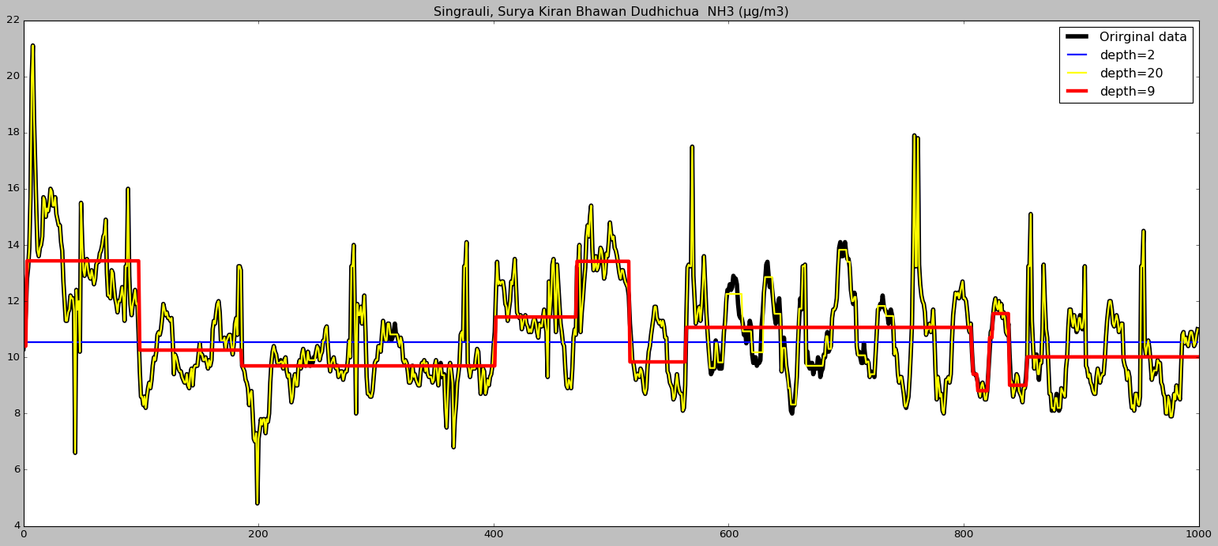

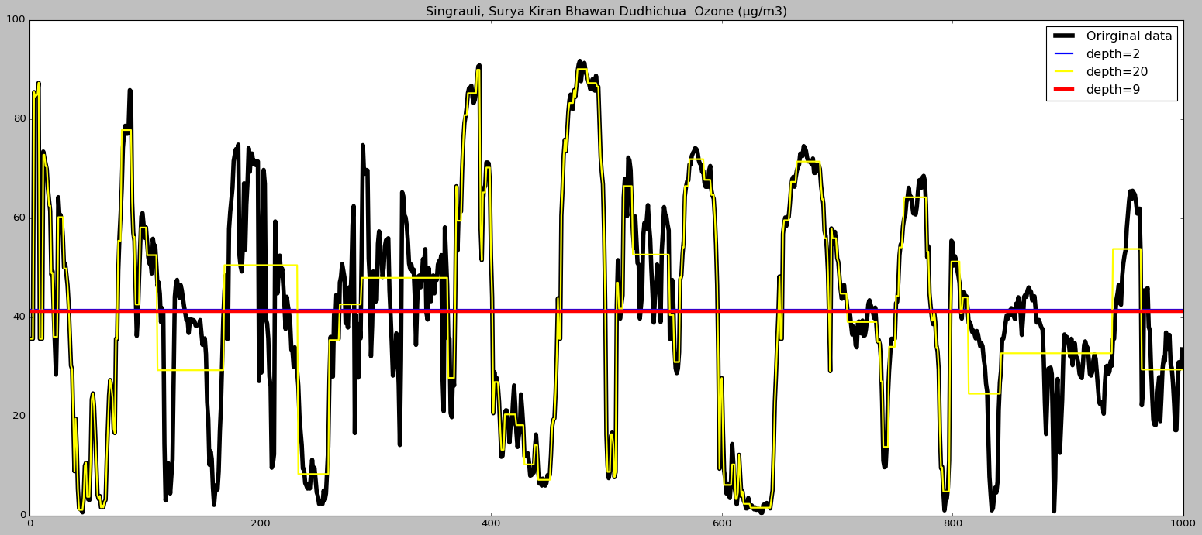

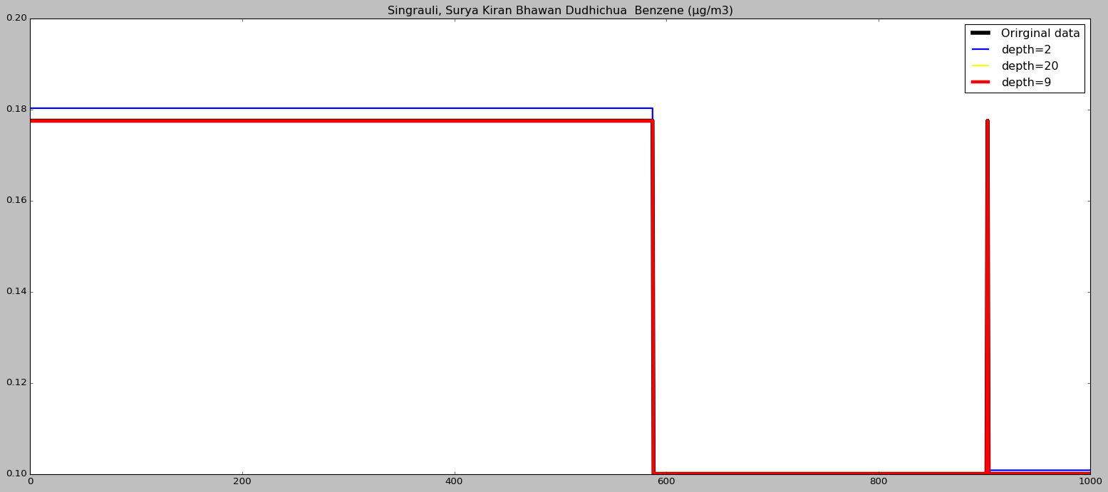

Here curves are overfitting at depth = 20 so we take depth = 10.

**K-nearest neighbours**

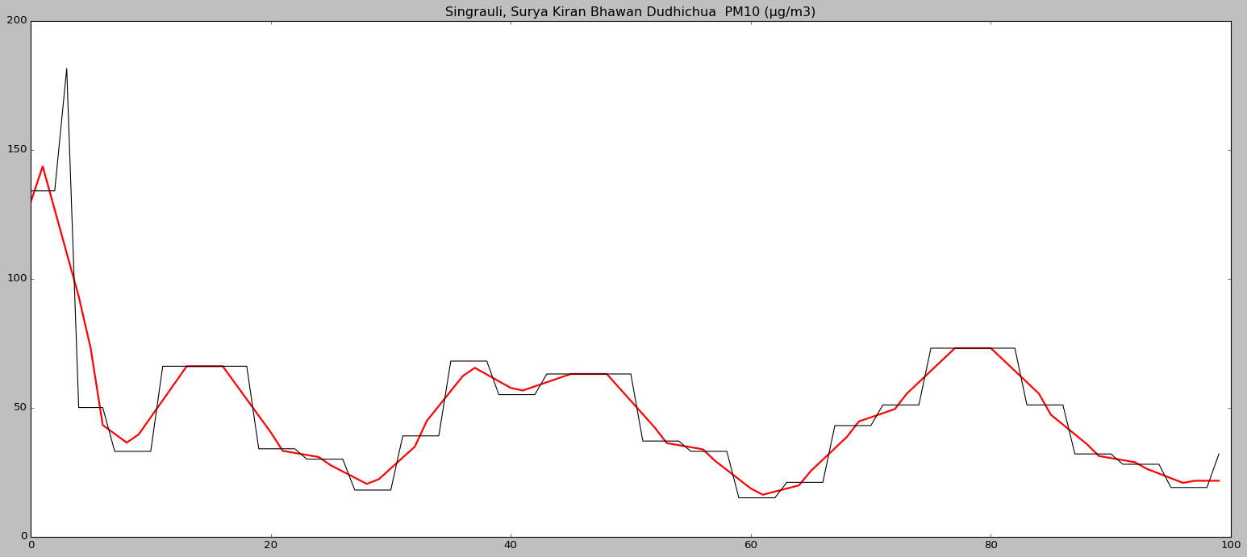

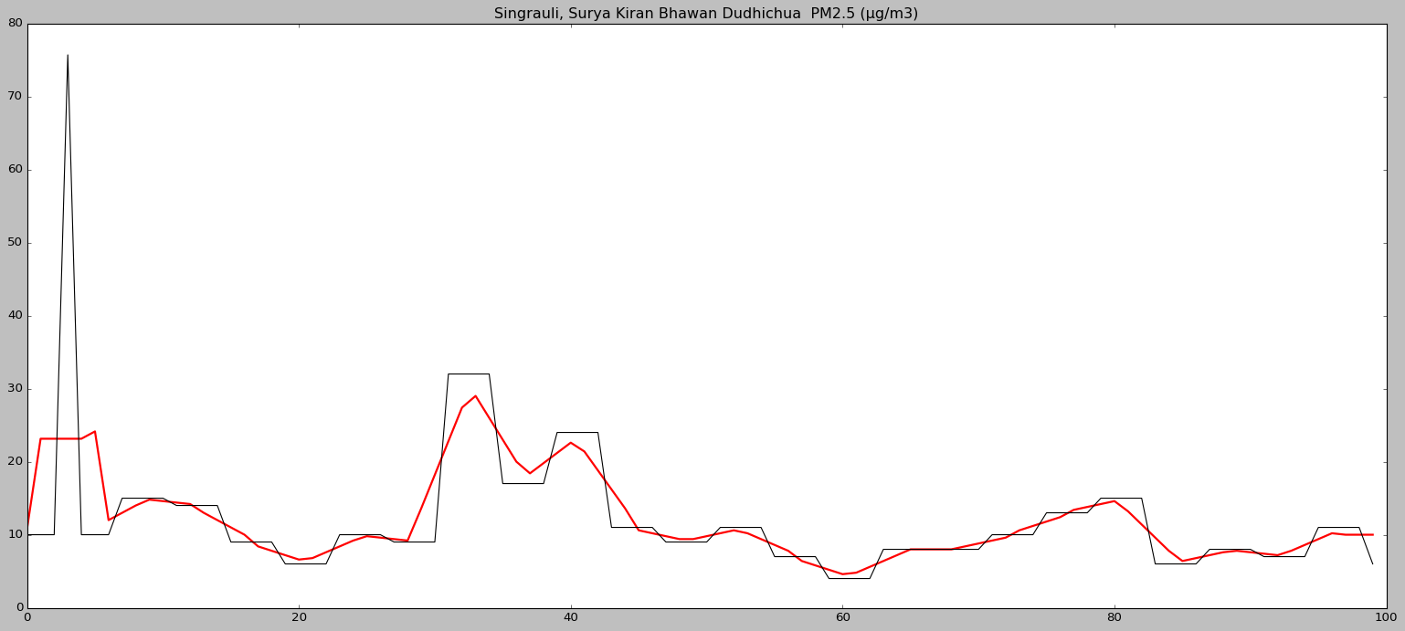

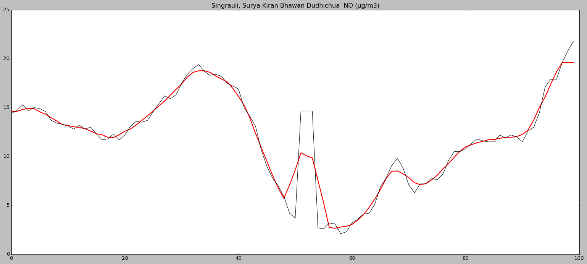

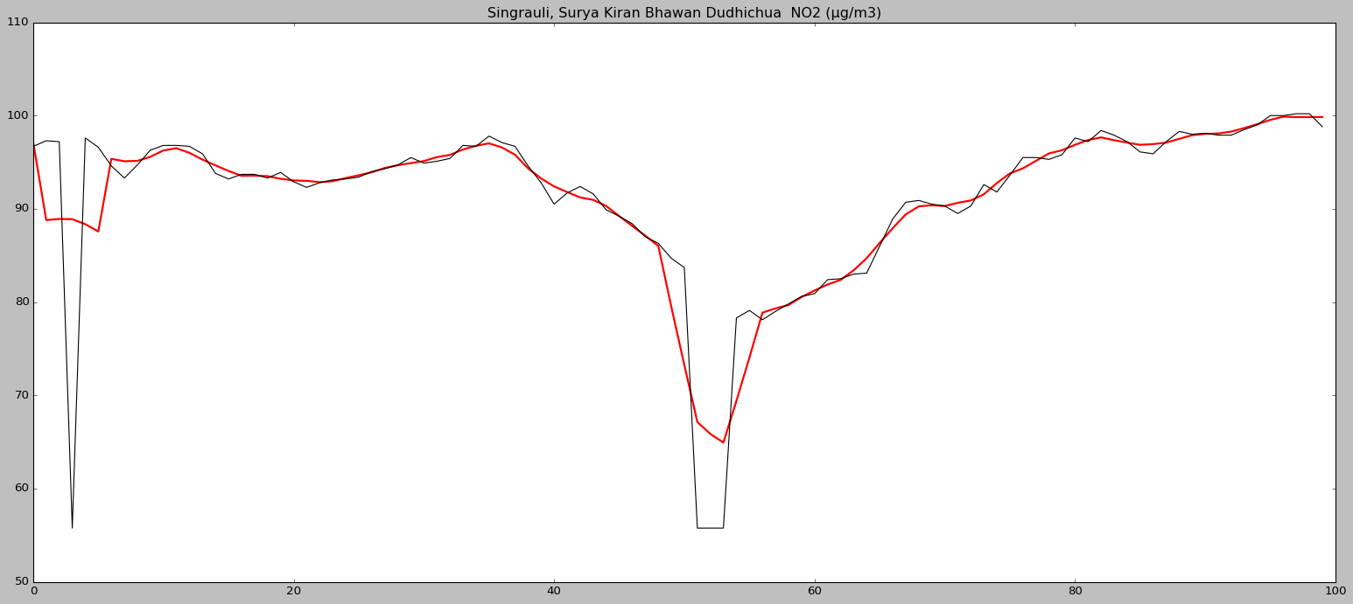

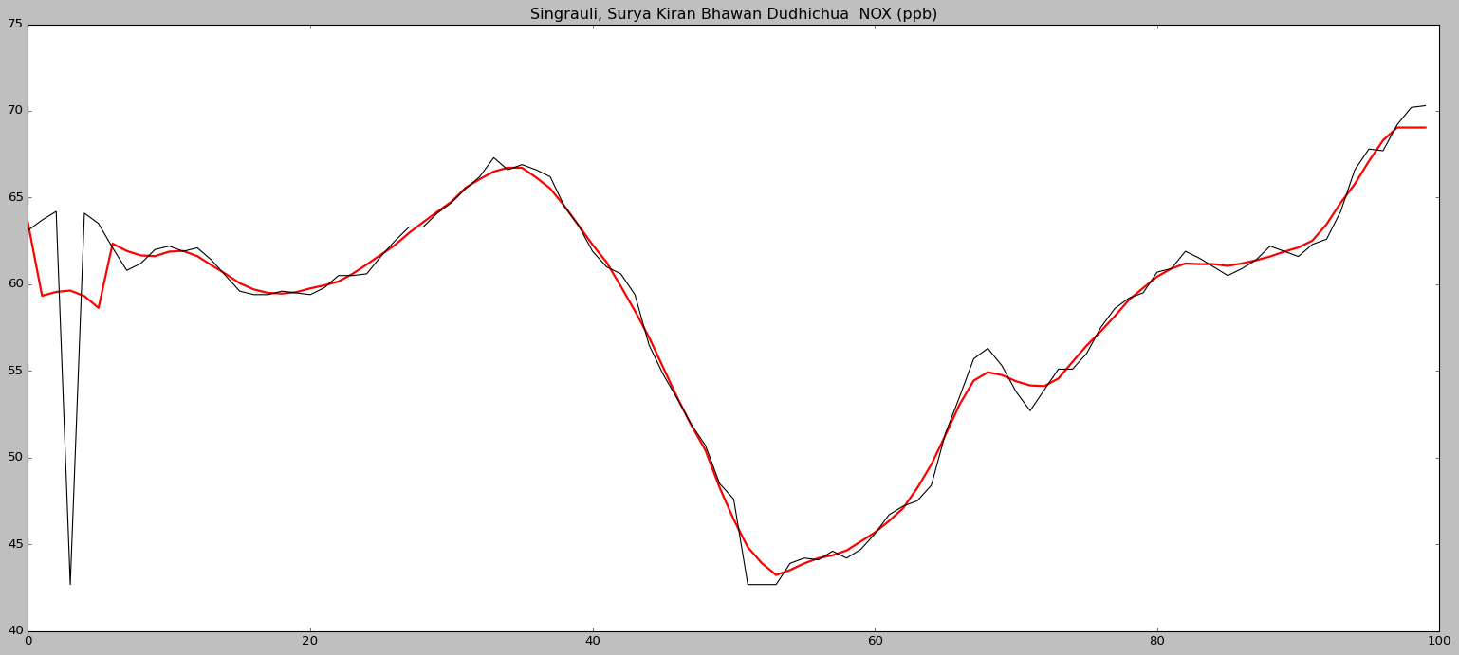

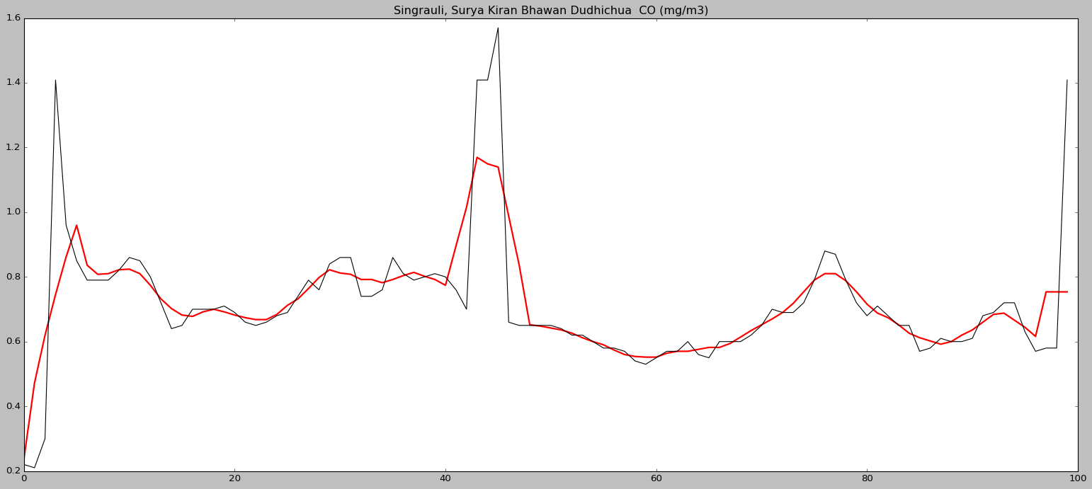

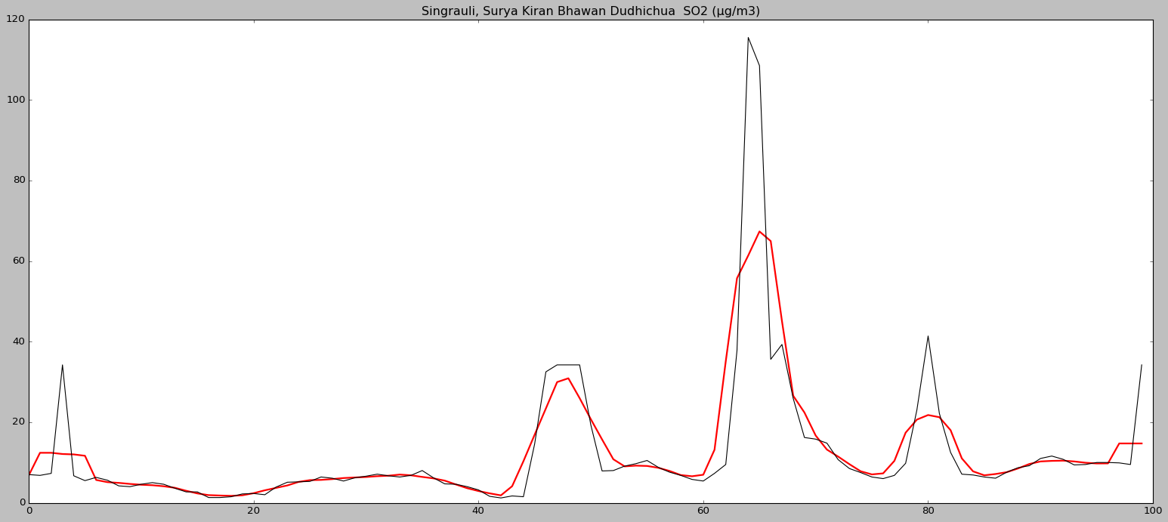

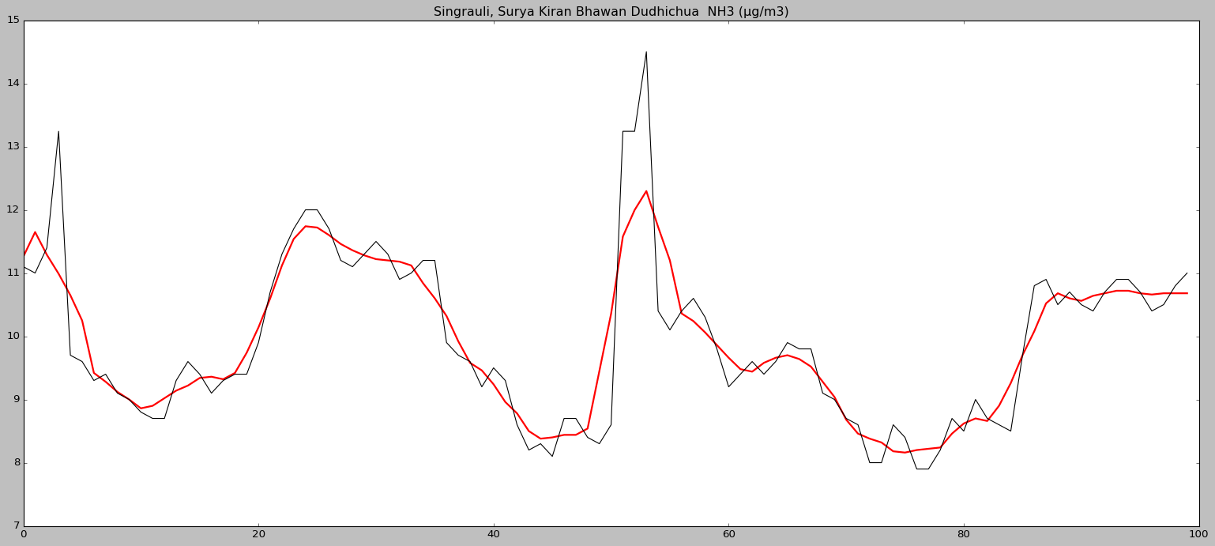

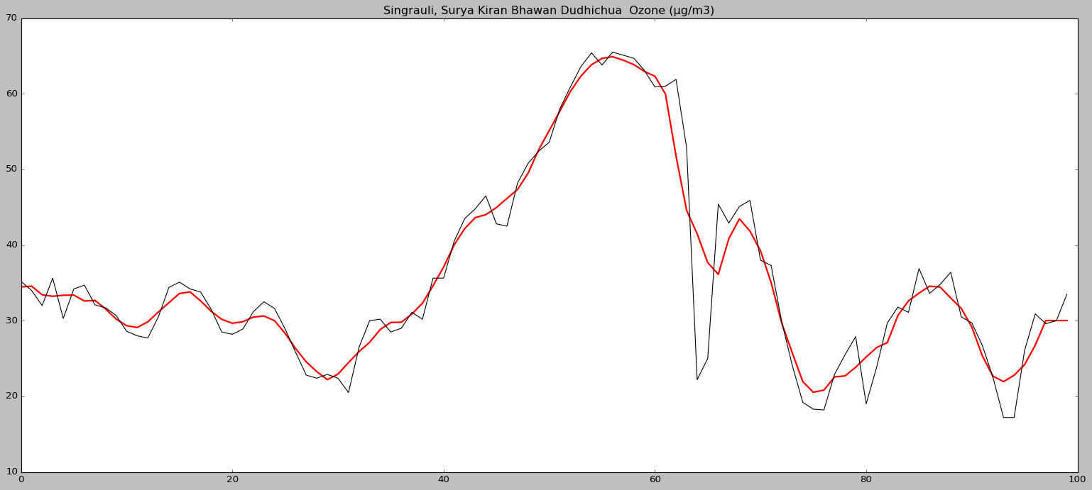

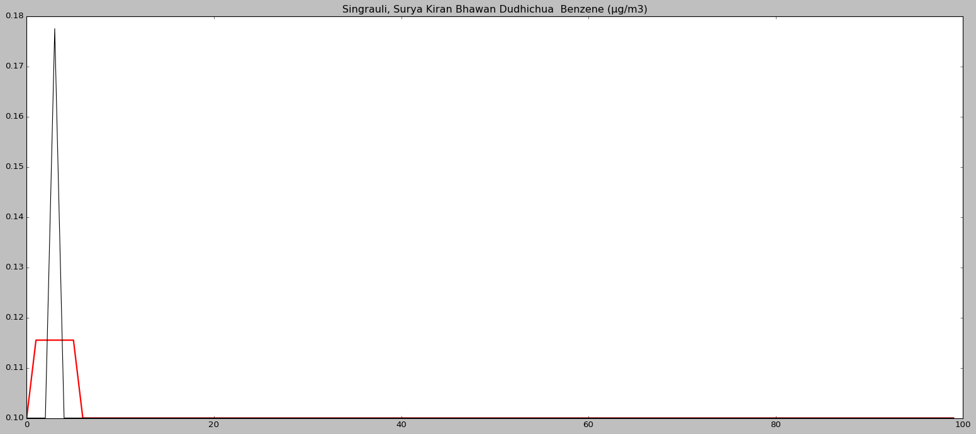

**Forecasting**

